**NAME: BINYANYA DEBORAH NYATICHI**

**CS NO: ADC-CSS02-25051**.

**DESCRIPTION: Week 2 Assignment 3**

**ASSIGNMENT: Lab on Microsoft Identity and Access Management Solutions**

**DATE: 05/04/2025**

# INTRODUCTION

In today's digital landscape, robust identity management is paramount for security, compliance, and user productivity. This lab series is designed to provide you with hands-on experience in key components of Microsoft's cutting-edge IAM platform, Microsoft Entra ID (formerly Azure AD).mThrough a series of focused labs, you will delve into critical functionalities that empower organizations to manage user identities, secure access to resources, and streamline administrative tasks. We will move beyond theoretical concepts and provide practical scenarios where you can configure and observe these powerful features in action.

This lab will guide you through the following essential areas:

* **Explore Microsoft Entra ID User Settings:** Gain a foundational understanding of how user accounts are managed within Microsoft Entra ID, including profile settings, contact information, and organizational relationships.
* **Microsoft Entra self-service password reset (SSPR):** Discover how to empower users to securely reset their own passwords, reducing helpdesk burden and improving user convenience.
* **Microsoft Entra Conditional Access:** Learn how to implement granular access control policies based on various conditions, such as user location, device compliance, and application sensitivity, to enhance security.
* **Explore Privileged Identity Management (PIM):** Understand how to manage, control, and monitor access to important resources within your organization by implementing just-in-time and approval-based privileged access.

# LAB: MICROSOFT ENTRA SELF-SERVICE PASSWORD RESET

This lab maps to the following Learn content:

* Learning Path: Describe the capabilities of of Microsoft Entra
* Module: Describe the authentication capabilities of Microsoft Entra ID
* Unit: Describe self-service password reset

# Lab scenario

In this lab, you, as an admin, will walk through the process of adding a user to the SSPR security group, which is already setup in your Microsoft 365 tenant. With SSPR enabled, you'll then assume the role of a user and go through the process of registering for SSPR and also resetting your password. Lastly, you as the admin, will be able to view audit logs and usage data & insights for SSPR.

## Task 1

In this task you, as the admin, will walk through the some of the available configuration settings for SSPR.

1. Open the Microsoft Edge browser. In the address bar, enter https://entra.microsoft.com and sign in with the Microsoft 365 admin credentials provided by your authorized lab hoster (ALH).
2. In the Sign-in window, enter admin@WWLx730857.onmicrosoft.com (where ZZZZZZ is your unique tenant ID provided by your ALH) then select Next.
3. Enter the admin password that should be provided by your lab hosting provider. Select Sign in.
4. Depending on your lab hoster and if this is the first time you are logging in to the tenant, you may be prompted to complete the MFA registration process. If so, follow the prompts on the screen to setup MFA.

Once you're signed-in, you're taken to the Microsoft 365 admin center page.

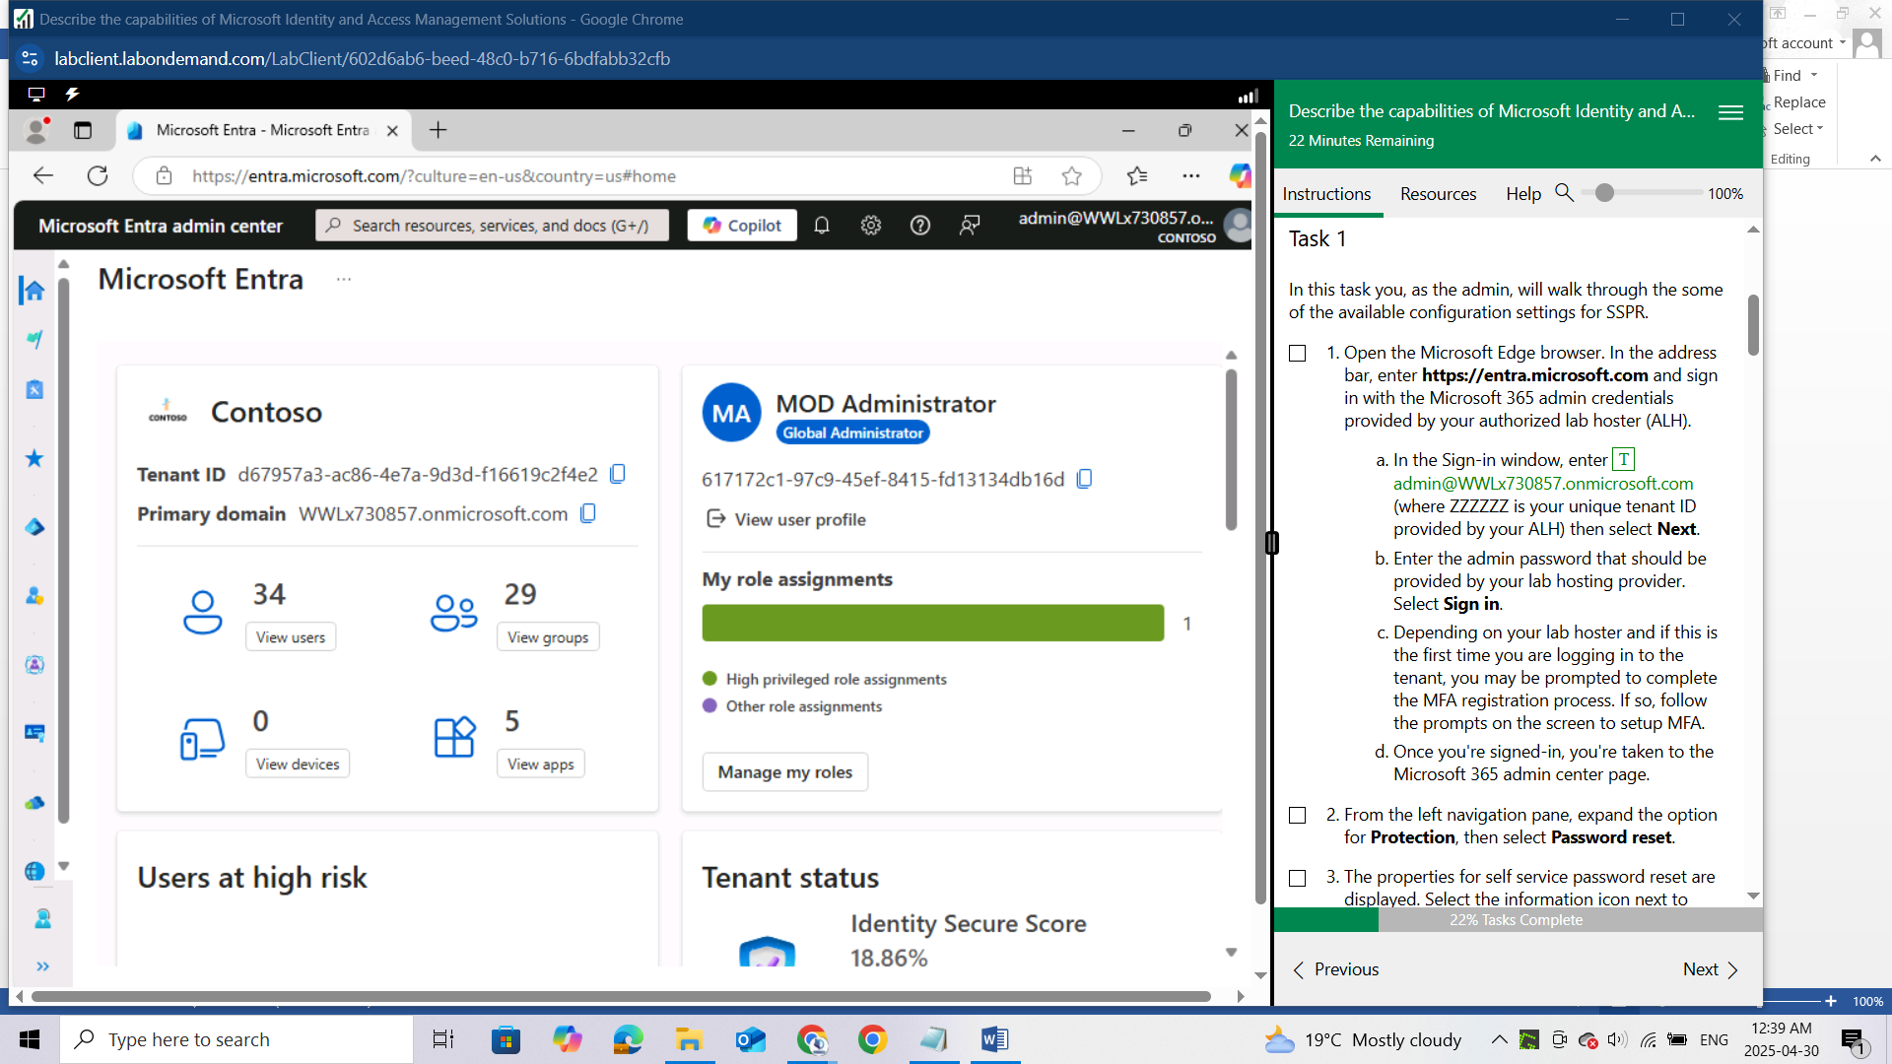

From the left navigation pane, expand the option for **Protection**, then select **Password reset.**

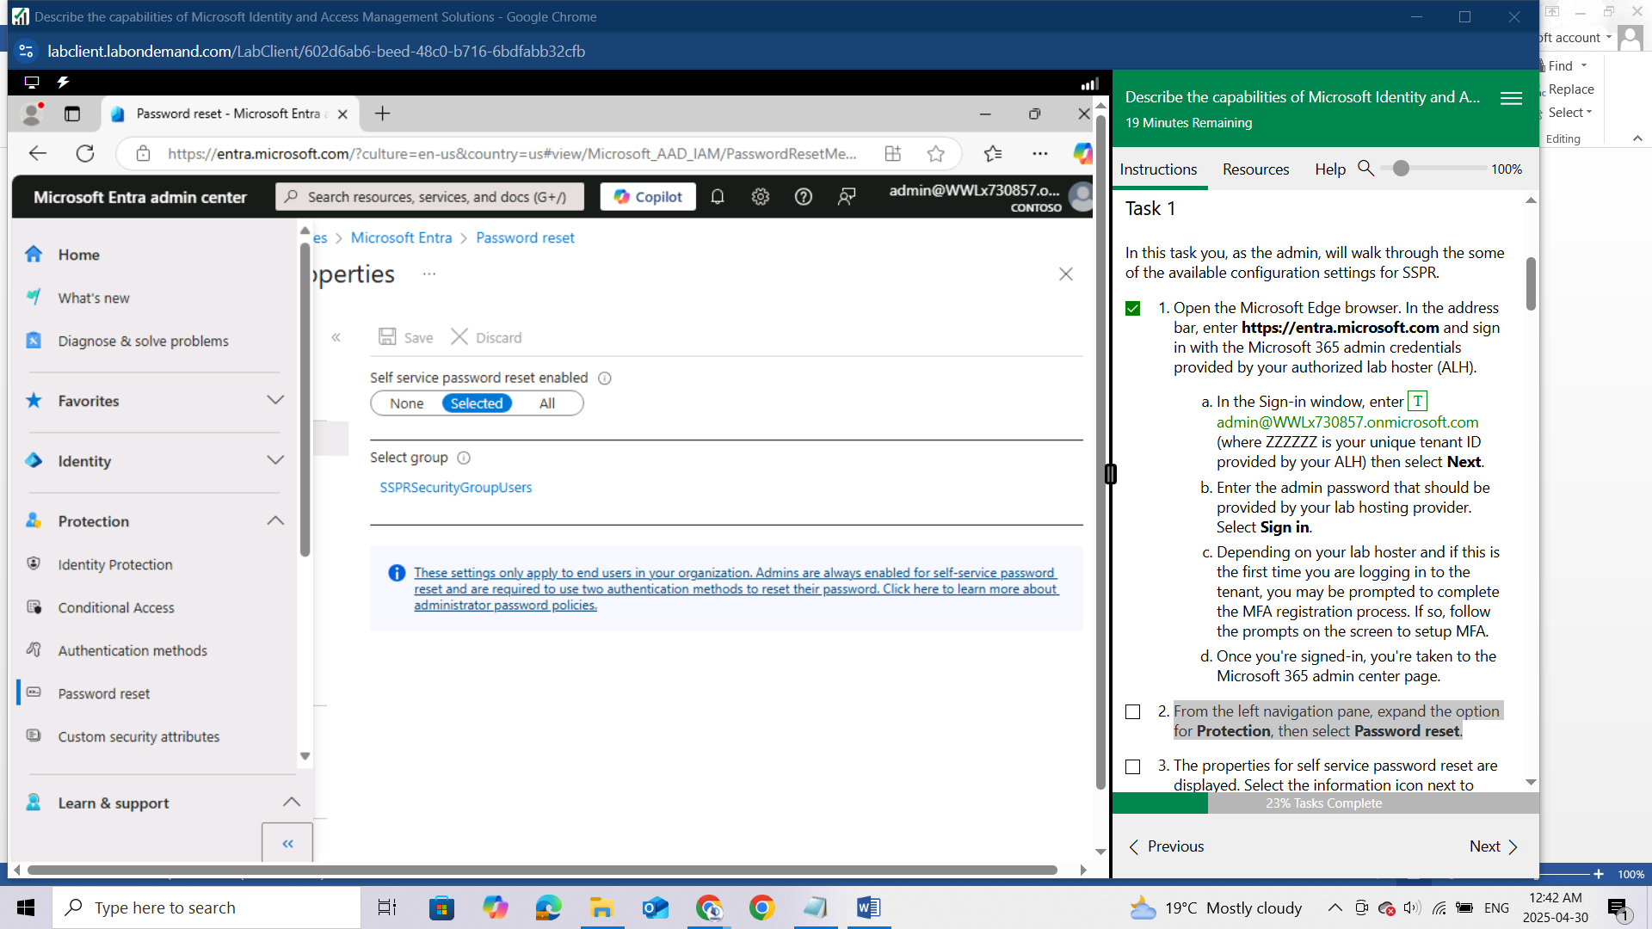

The properties for self service password reset are displayed. Select the information icon next to where it says **Self services password** **reset enabled** to view what the description. Ensure that **Selected** is highlighted in blue. Now put your cursor over the information icon next to where it says Select group and note that it says, "**Defines the group of users who are allowed to reset their own passwords."** You must include users in the group, you can’t individually select users. Notice that there is a group already listed - SSPRSecurityGroupUsers (this group was preconfigured as part your Microsoft 365 tenant). Lastly, note the blue information box, "**These settings only apply to end users in your organization. Admins are always enabled for self-service password reset and are required to use two authentication methods to reset their password."**

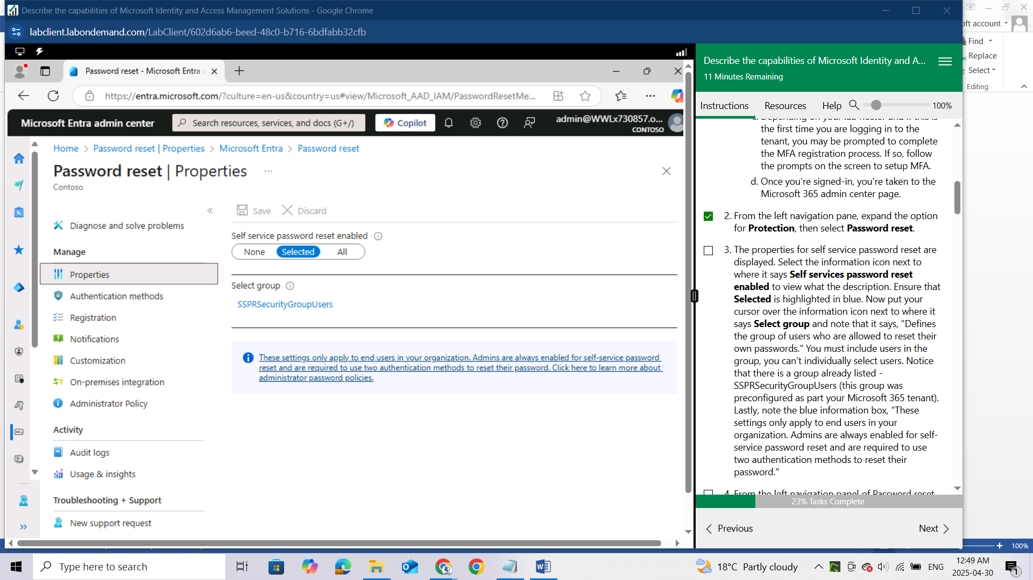

2

3

1

From the left navigation panel of Password reset, select **Authentication Methods**.

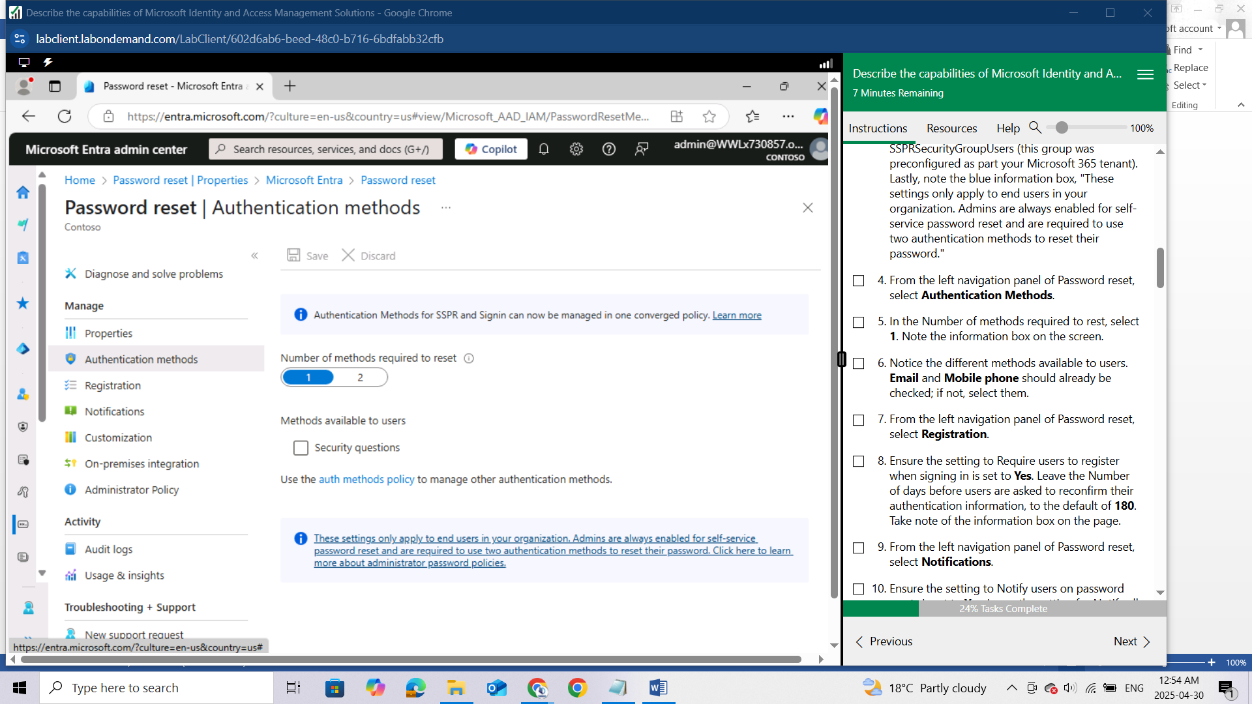

In the Number of methods required to rest, select **1**. Note the information box on the screen.

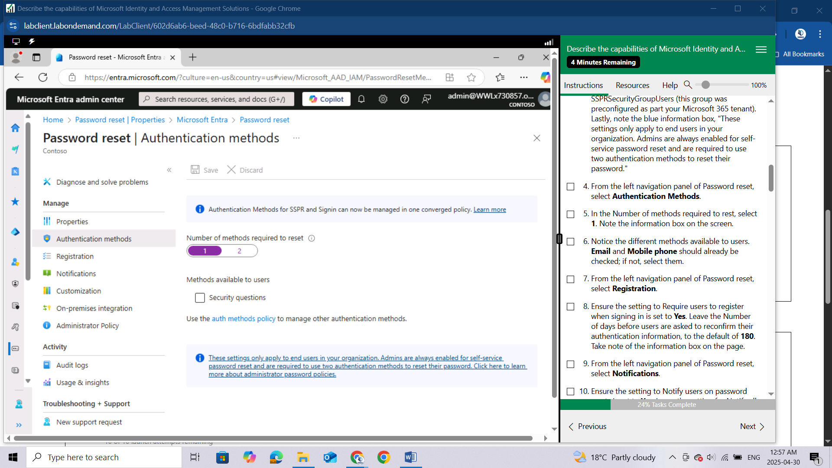

Notice the different methods available to users. **Email** and **Mobile phone** should already be checked; if not, select them.

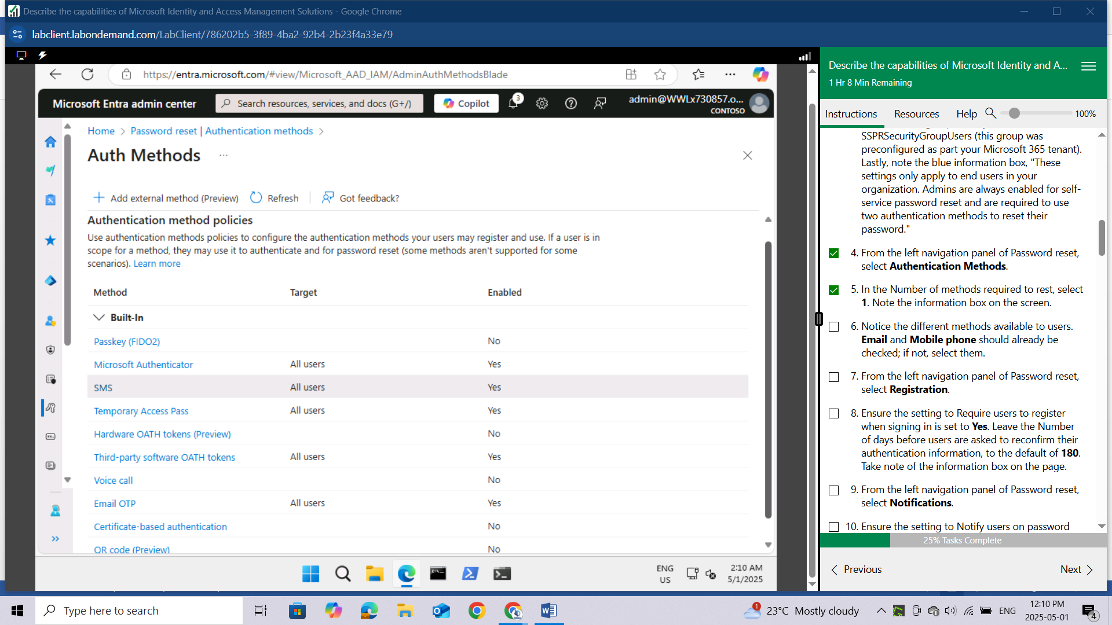

From the left navigation panel of Password reset, select **Registration**.

Ensure the setting to Require users to register when signing in is set to **Yes**. Leave the Number of days before users are asked to reconfirm their authentication information, to the default of **180**. Take note of the information box on the page.

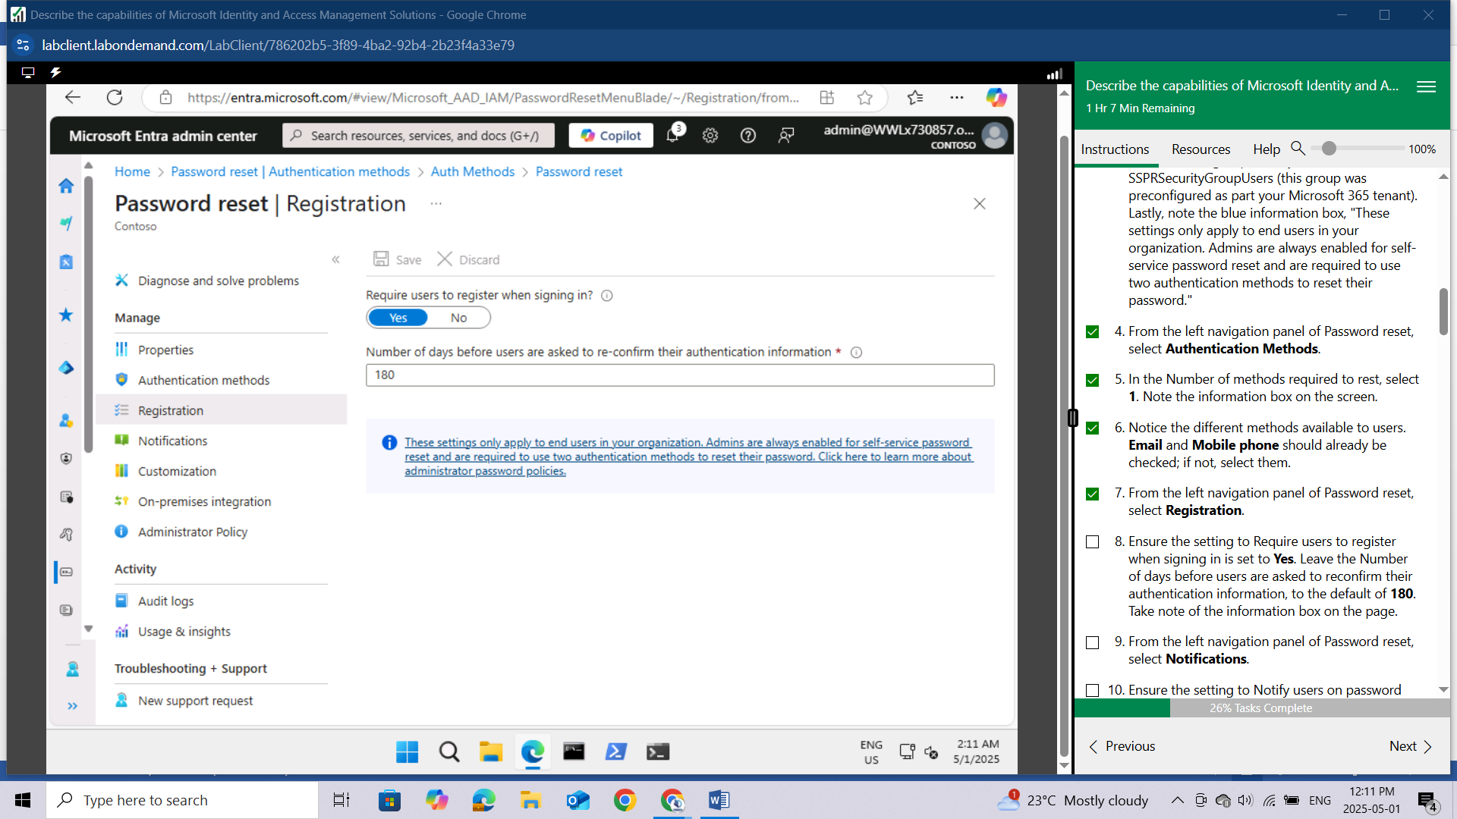

From the left navigation panel of Password reset, select **Notifications**.

Ensure the setting to Notify users on password resets is set to **Yes**. Leave the setting for Notify all admins when other admins reset their password to **No**.

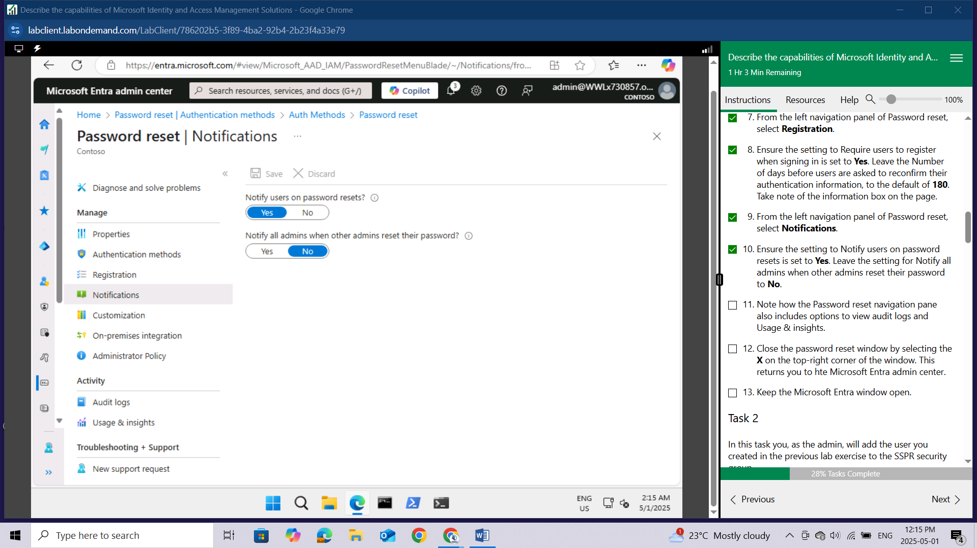

Note how the Password reset navigation pane also includes options to view audit logs and Usage & insights.

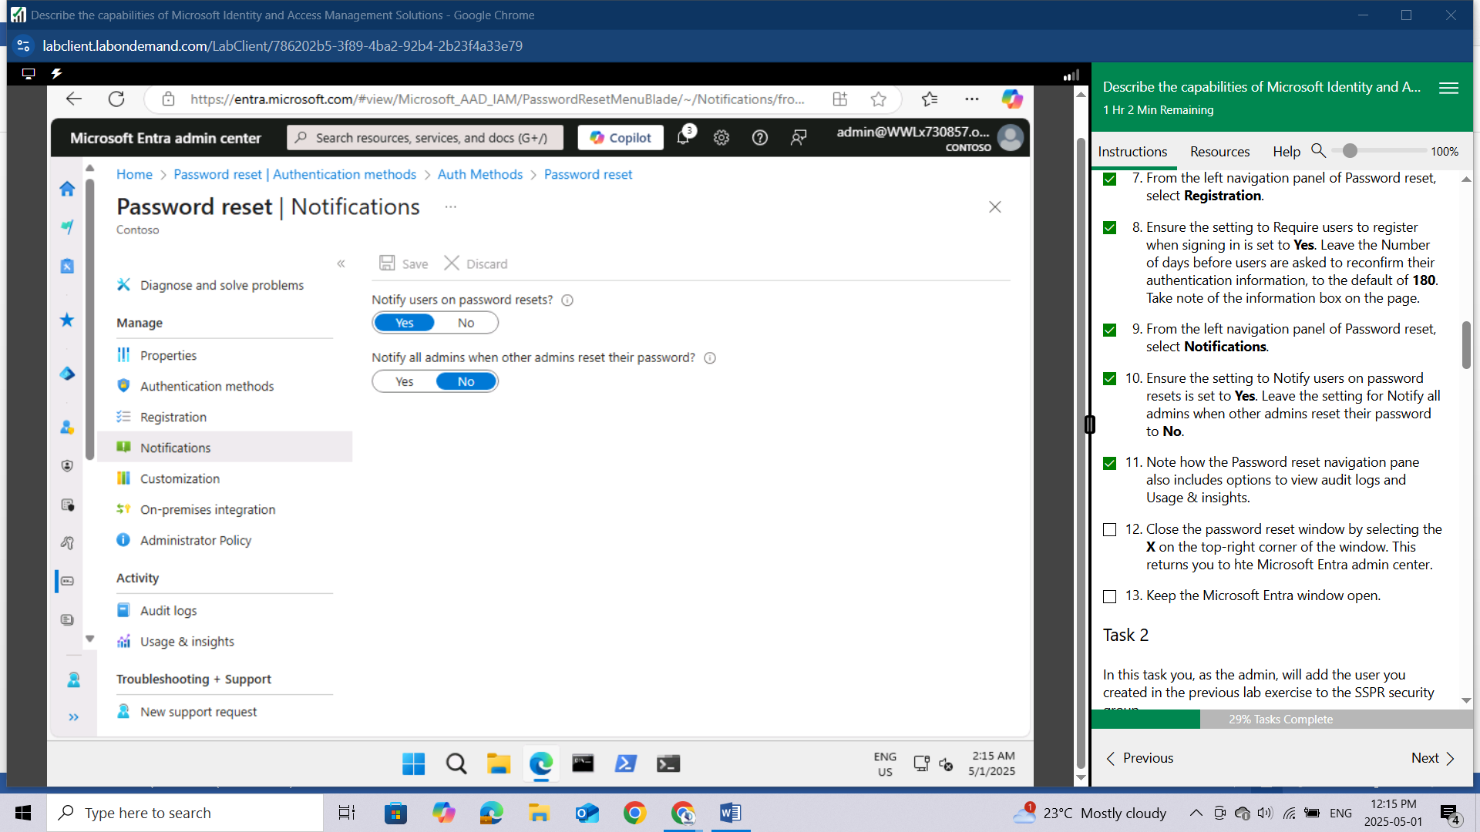

Close the password reset window by selecting the X on the top-right corner of the window. This returns you to the Microsoft Entra admin center.

Keep the Microsoft Entra window open.

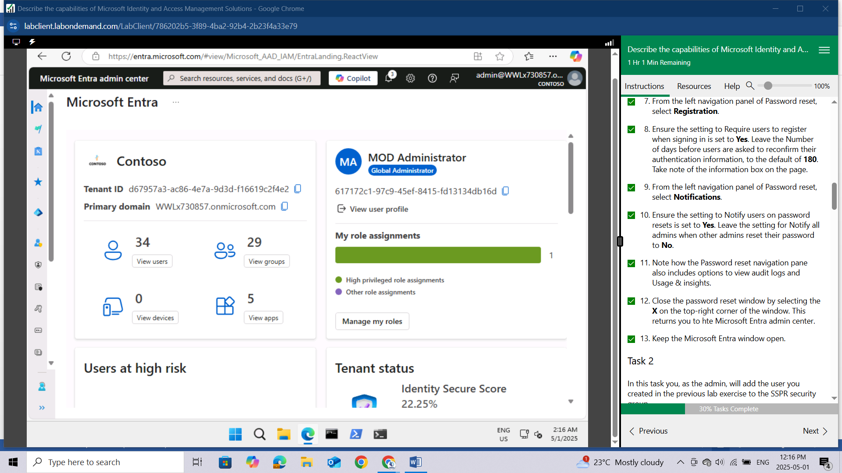

## Task 2

In this task you, as the admin, will add the user you created in the previous lab exercise to the SSPR security group.

Open the browser tab for the home page of the Microsoft Entra Admin center entra.microsoft.com. If needed, expand Identity.

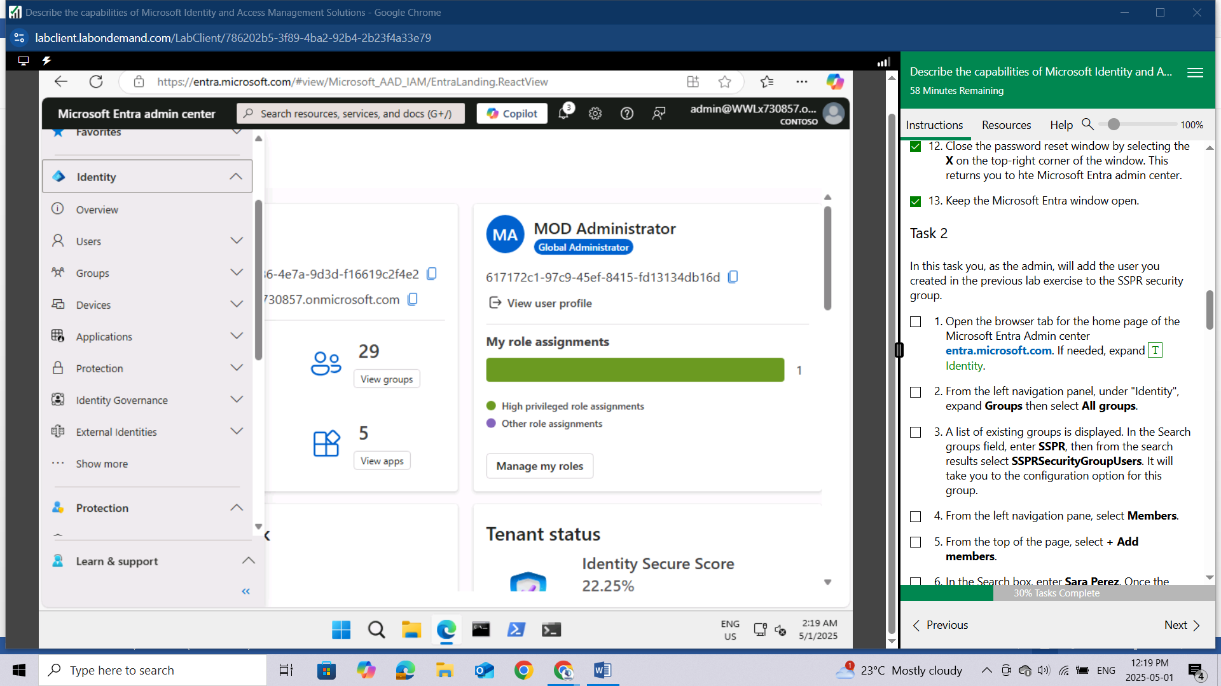

From the left navigation panel, under "Identity", expand **Groups** then select **All groups.**

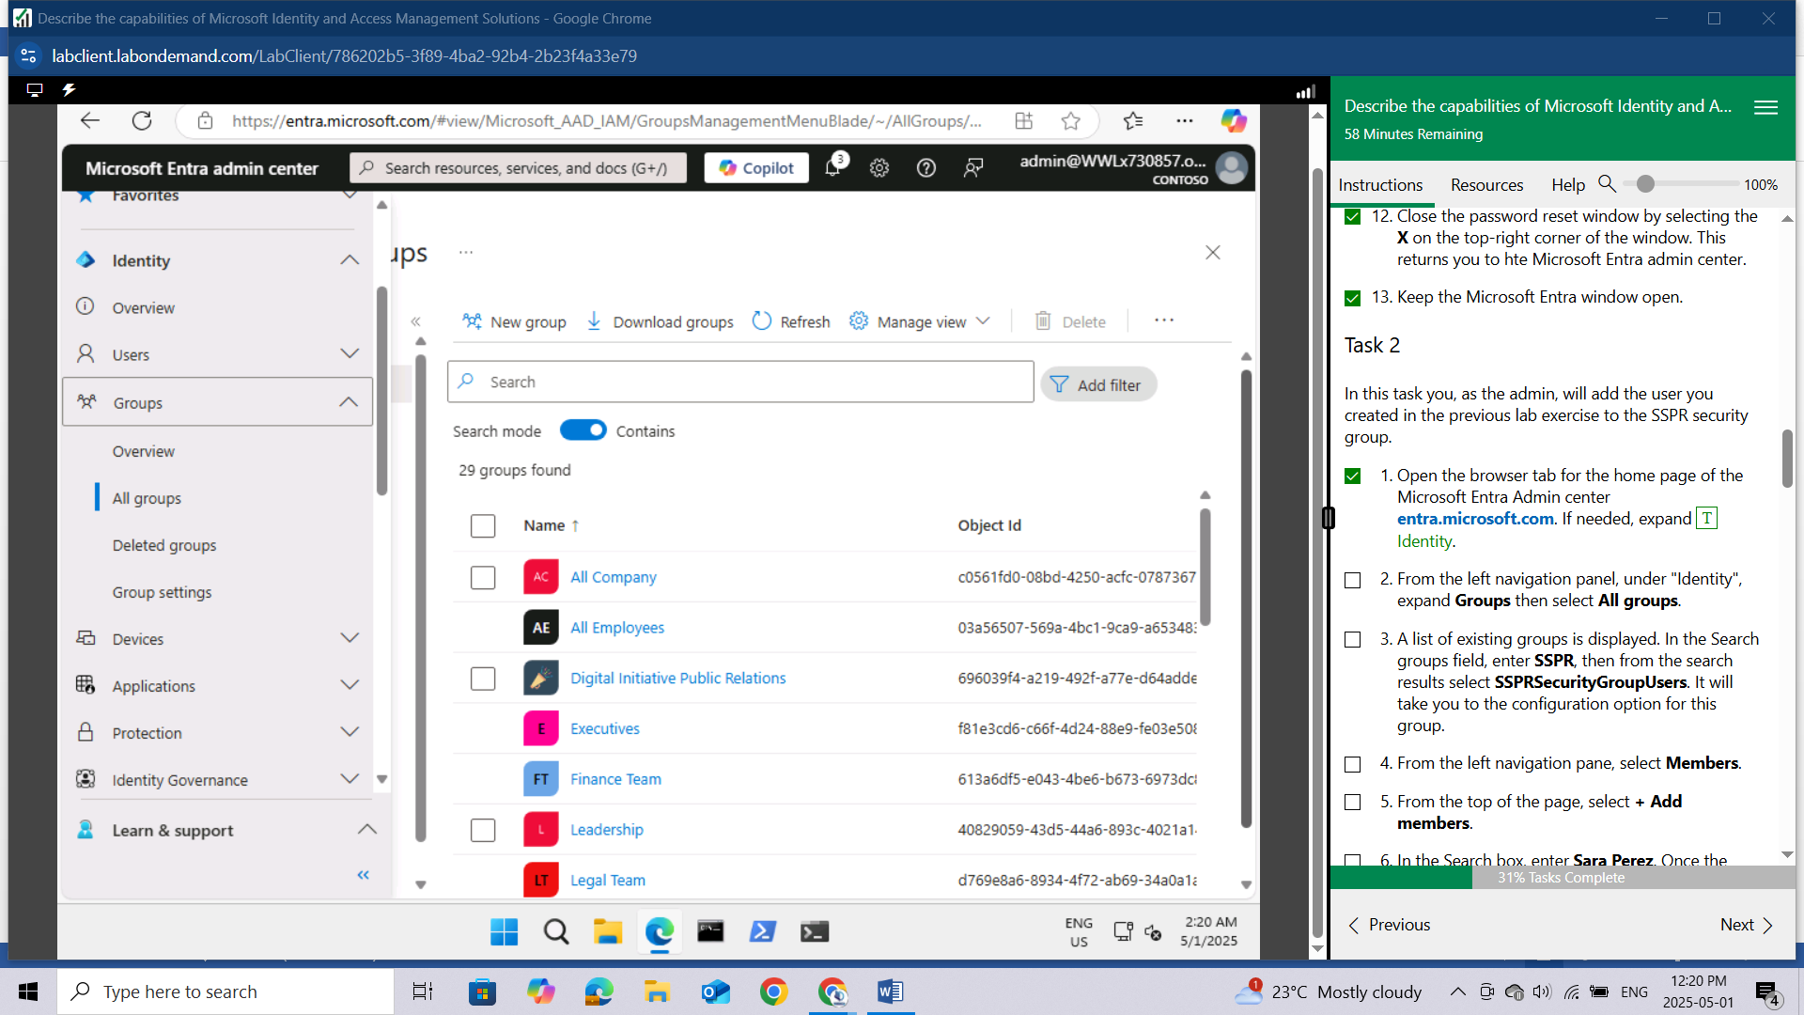

A list of existing groups is displayed. In the Search groups field, enter SSPR, then from the search results select SSPRSecurityGroupUsers. 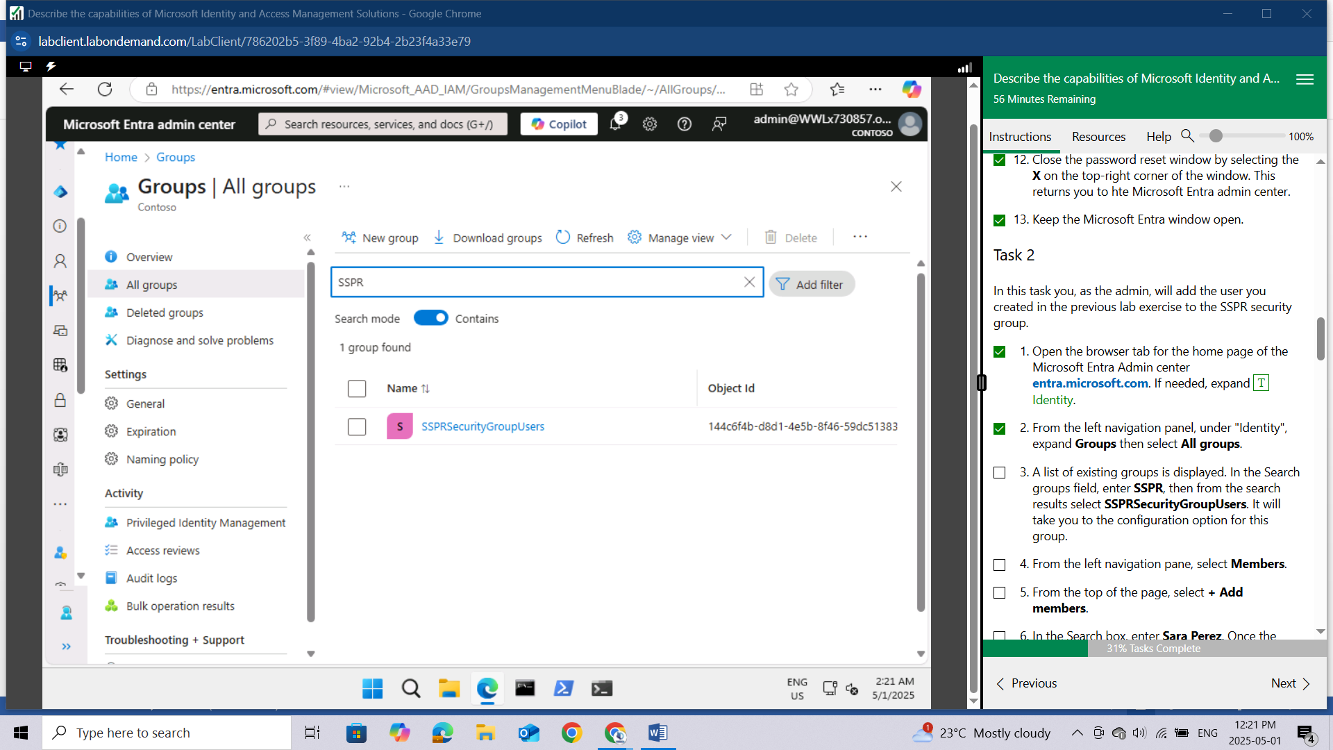

It will take you to the configuration option for this group.

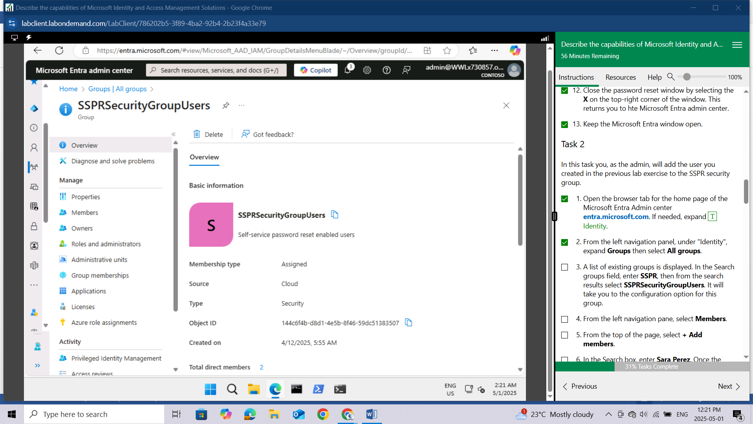

From the left navigation pane, select Members.

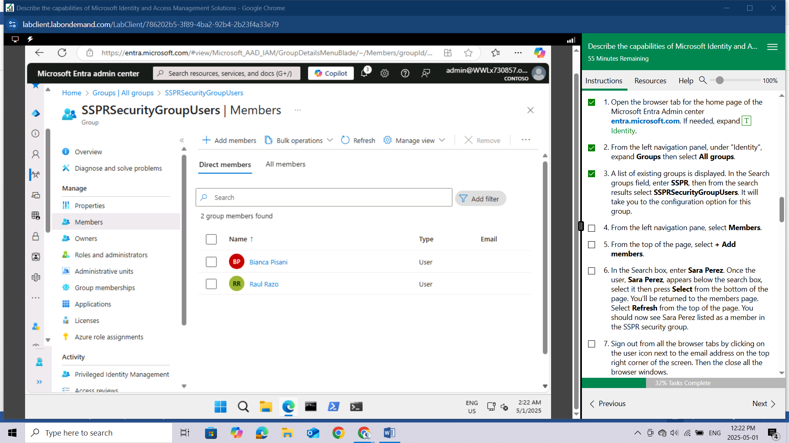

From the top of the page, select + Add members.

In the Search box, enter Sara Perez. Once the user, Sara Perez, appears below the search box, select it then press Select from the bottom of the page.

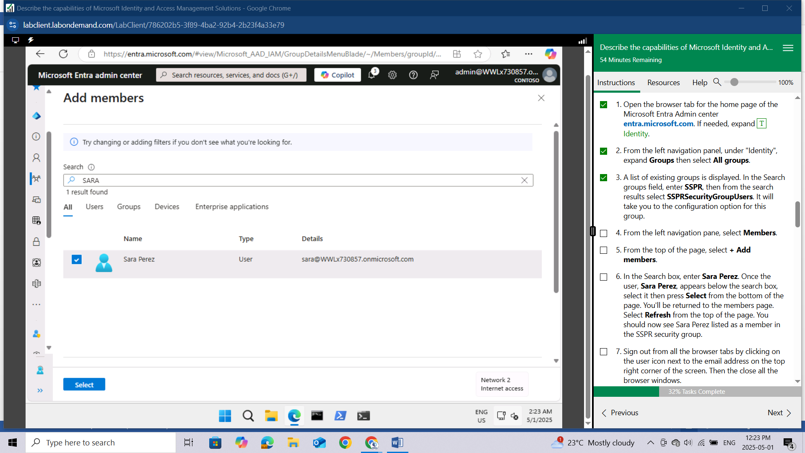

You'll be returned to the members page. Select Refresh from the top of the page. You should now see Sara Perez listed as a member in the SSPR security group.

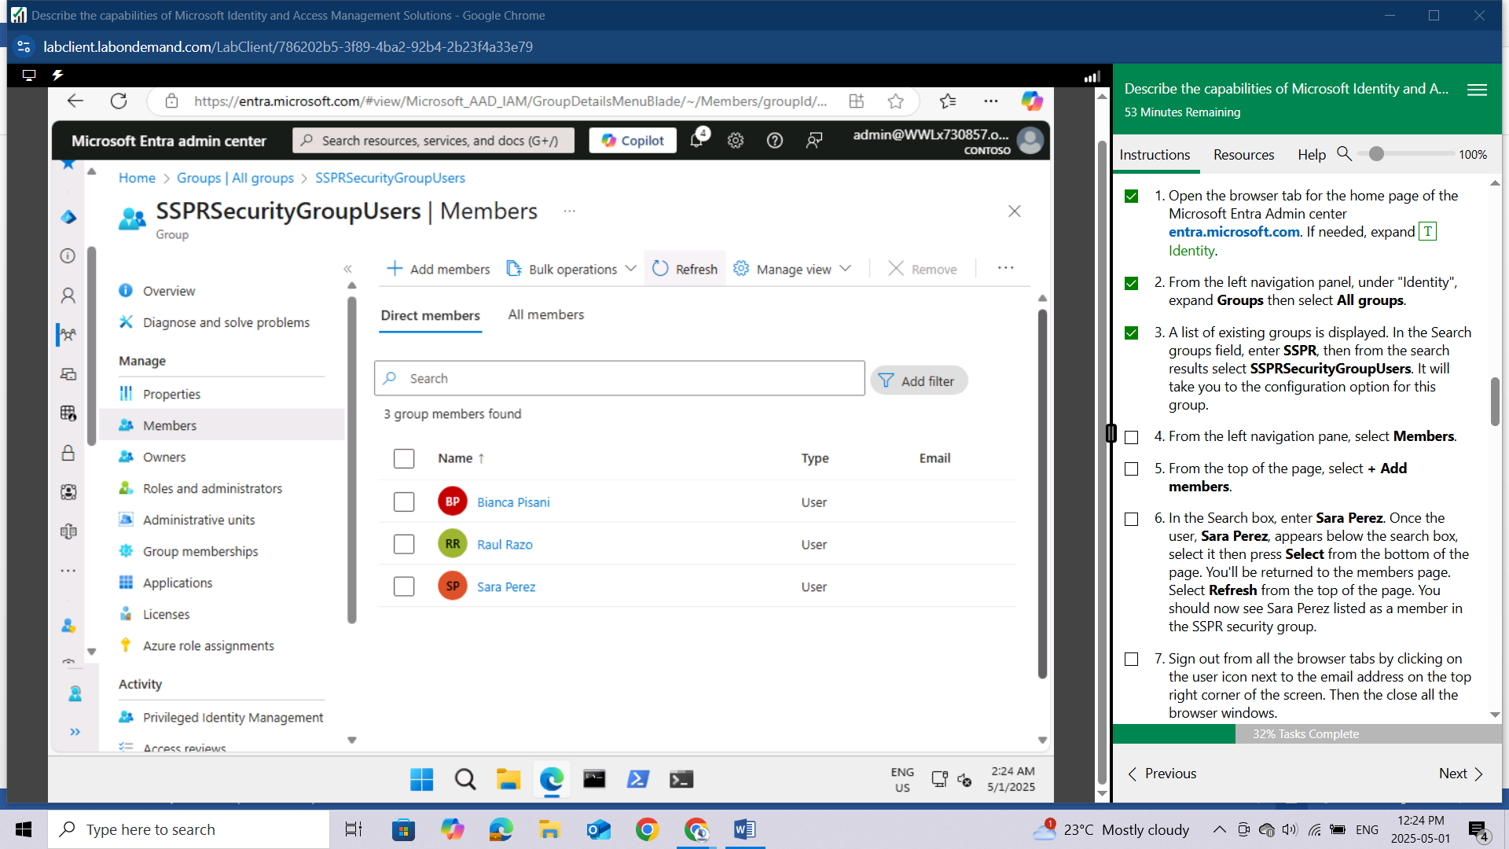

Sign out from all the browser tabs by clicking on the user icon next to the email address on the top right corner of the screen. Then the close all the browser windows.

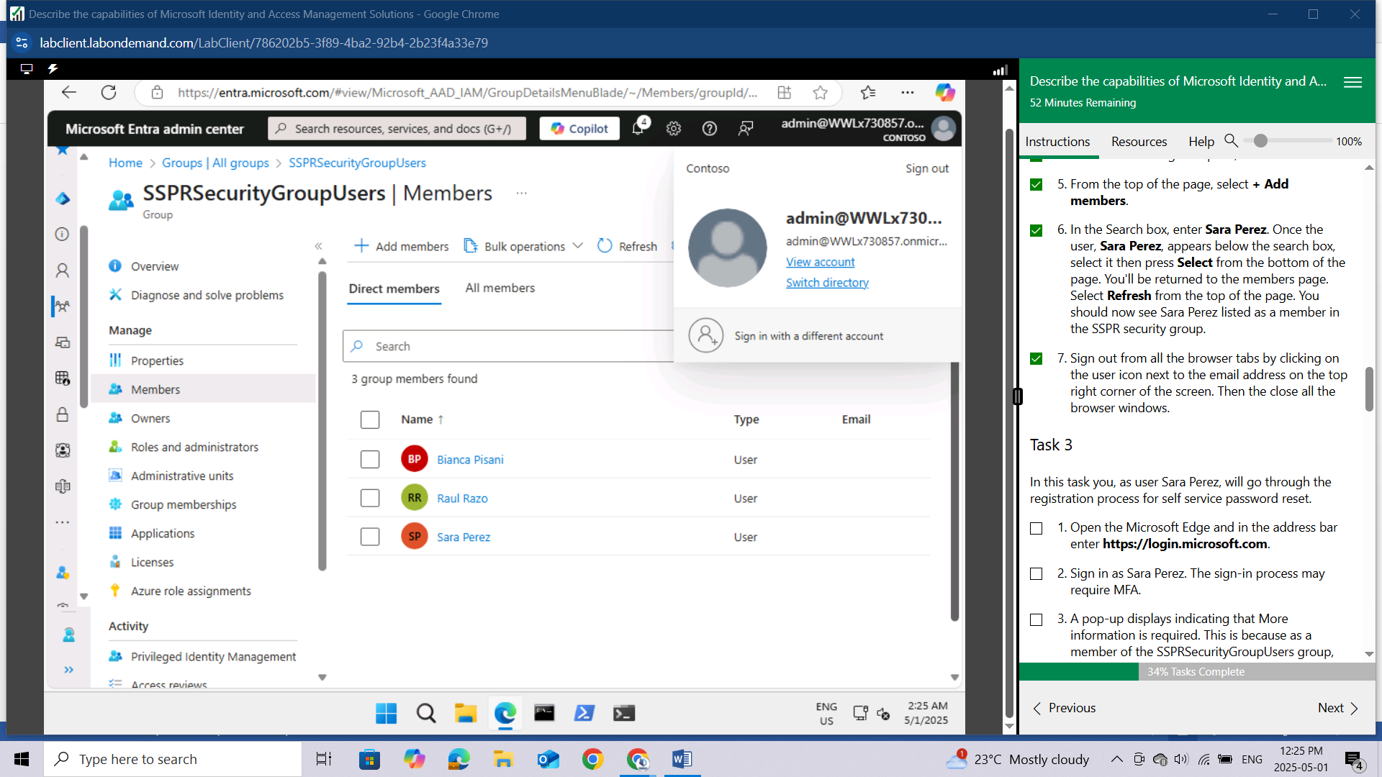

## Task 3

In this task you, as user Sara Perez, will go through the registration process for self service password reset.

Open the Microsoft Edge and in the address bar enter <https://login.microsoft.com>.

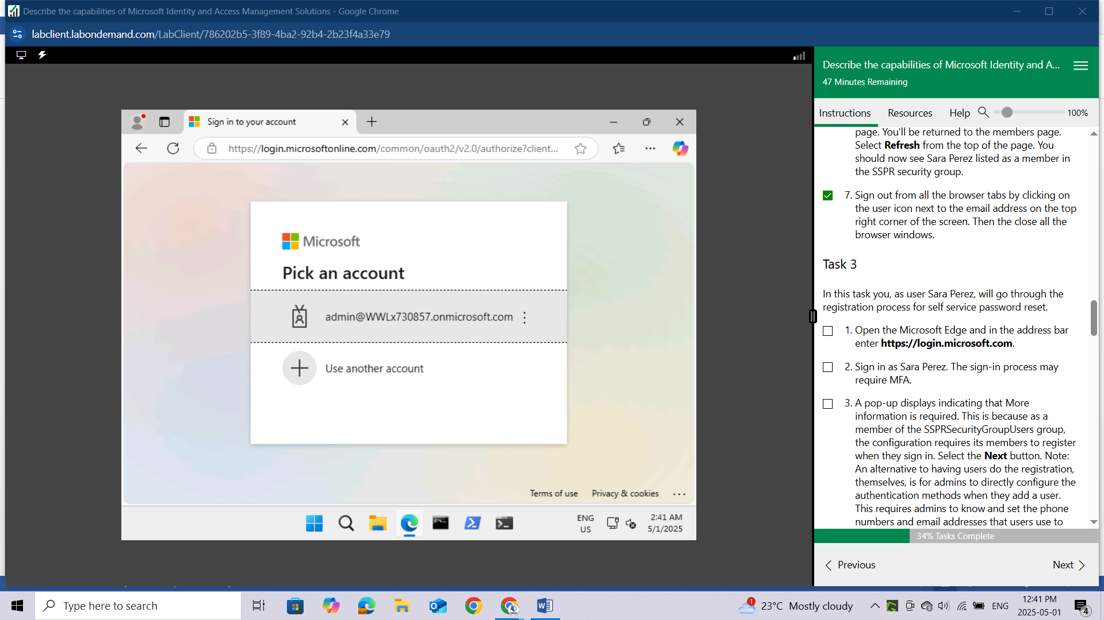

Sign in as Sara Perez.

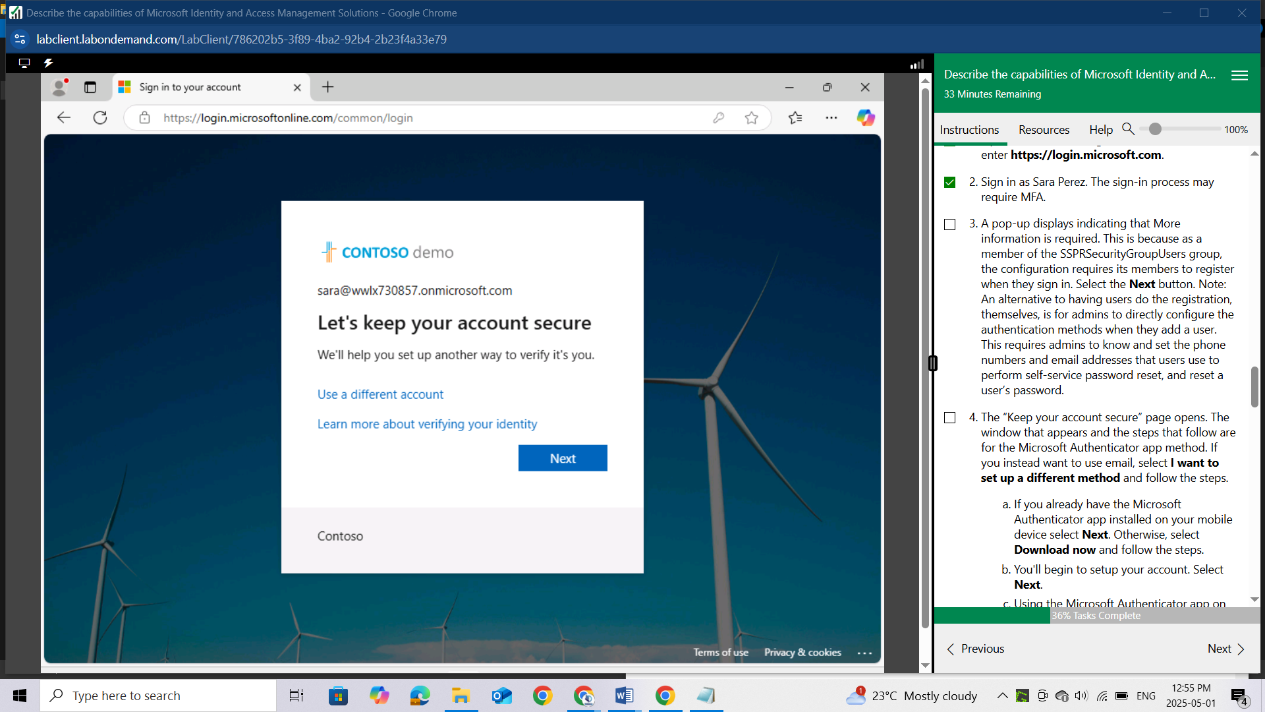

The sign-in process may require MFA.

A pop-up displays indicating that More information is required. This is because as a member of the SSPRSecurityGroupUsers group, the configuration requires its members to register when they sign in. Select the Next button. Note: An alternative to having users do the registration, themselves, is for admins to directly configure the authentication methods when they add a user. This requires admins to know and set the ​phone numbers and email addresses that users use to perform self-service password reset, and reset a user’s password.

The “Keep your account secure” page opens. The window that appears and the steps that follow are for the Microsoft Authenticator app method. If you instead want to use email, select I want to set up a different method and follow the steps.

If you already have the Microsoft Authenticator app installed on your mobile device select Next. Otherwise, select Download now and follow the steps.

You'll begin to setup your account. Select Next.

Using the Microsoft Authenticator app on your mobile device, select the + to add an account and select Work or school account.

Select the option to Scan the QR code, then using your mobile device, scan the QR code on your PC screen .

Follow the steps on your PC and mobile device, then select Next.

Once you've setup your security info, you'll see a Success window. Select Done.

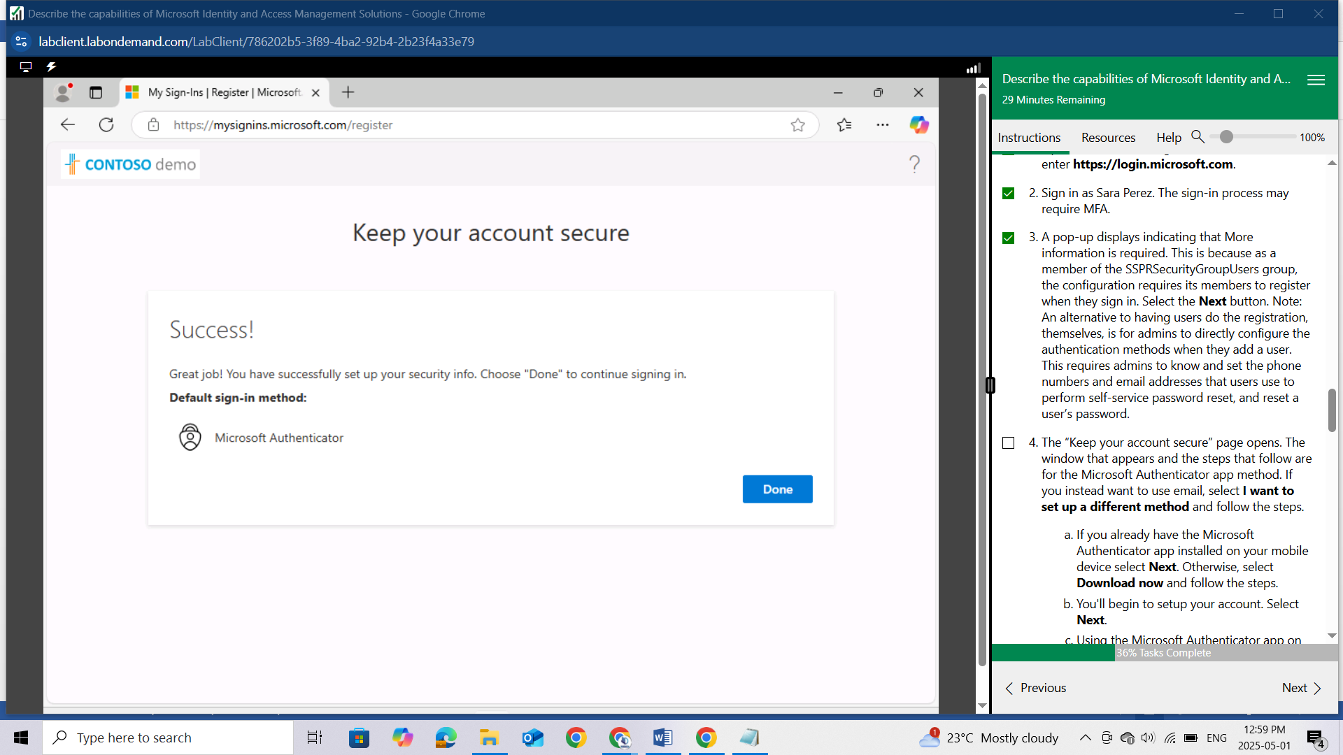

You can now complete your sign-in. If you see that your sign-in time has expired, just reenter the password.

Sign out from all the browser tabs by clicking on the user icon next to the email address on the top right corner of the screen. Then the close all the browser windows.

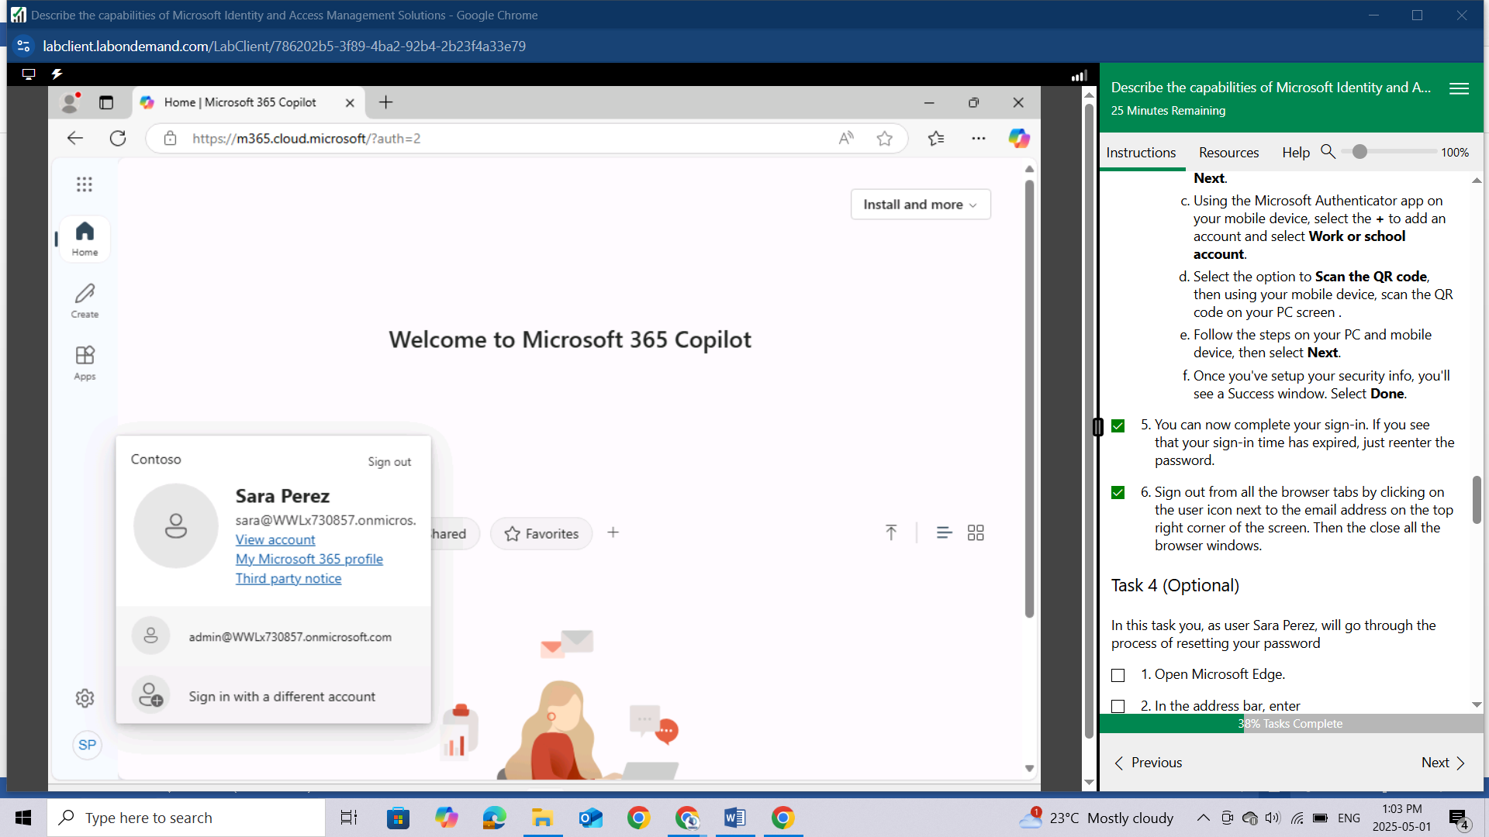

## Task 4 (Optional)

In this task you, as user Sara Perez, will go through the process of resetting your password

Open Microsoft Edge.

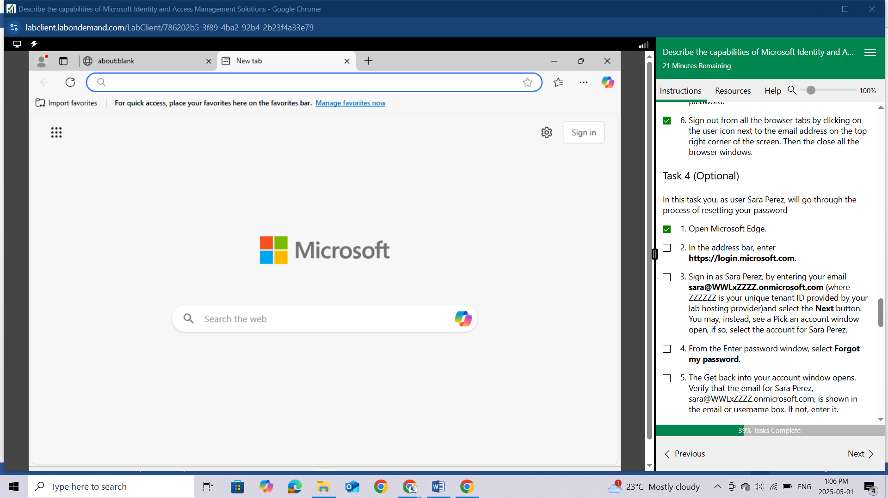

In the address bar, enter https://login.microsoft.com.

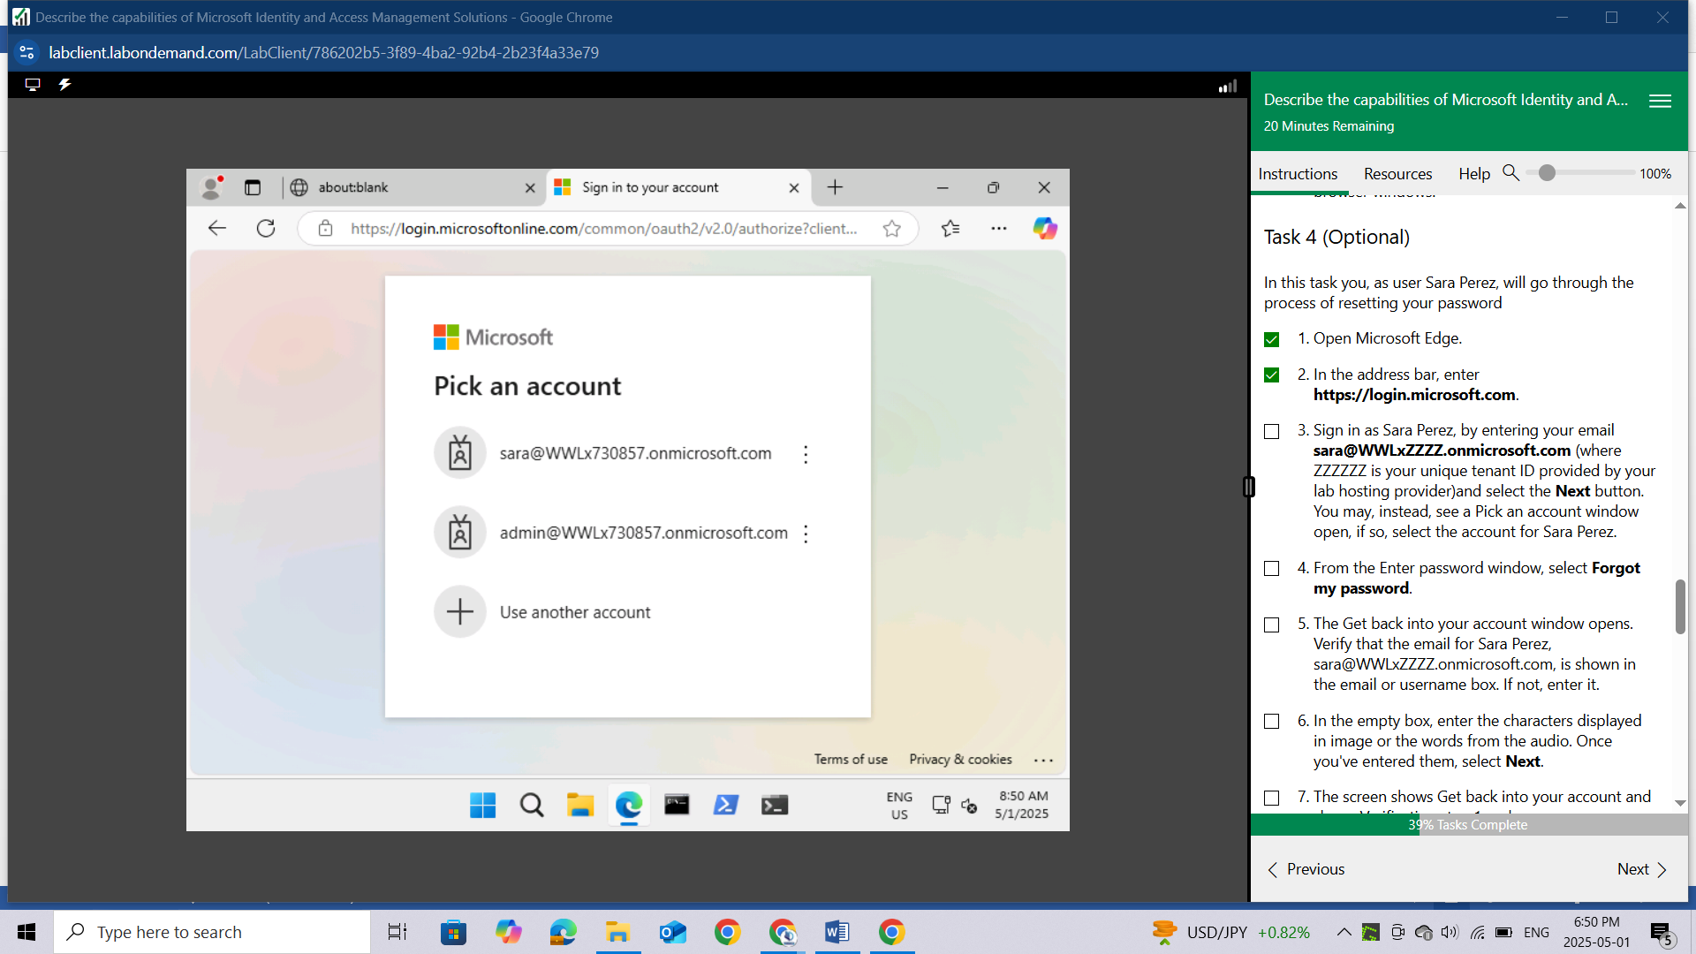

Sign in as Sara Perez, by entering your email **sara@WWLxZZZZ.onmicrosoft.com** (where ZZZZZZ is your unique tenant ID provided by your lab hosting provider)and select the Next button. You may, instead, see a Pick an account window open, if so, select the account for Sara Perez.

From the Enter password window, select Forgot my password.

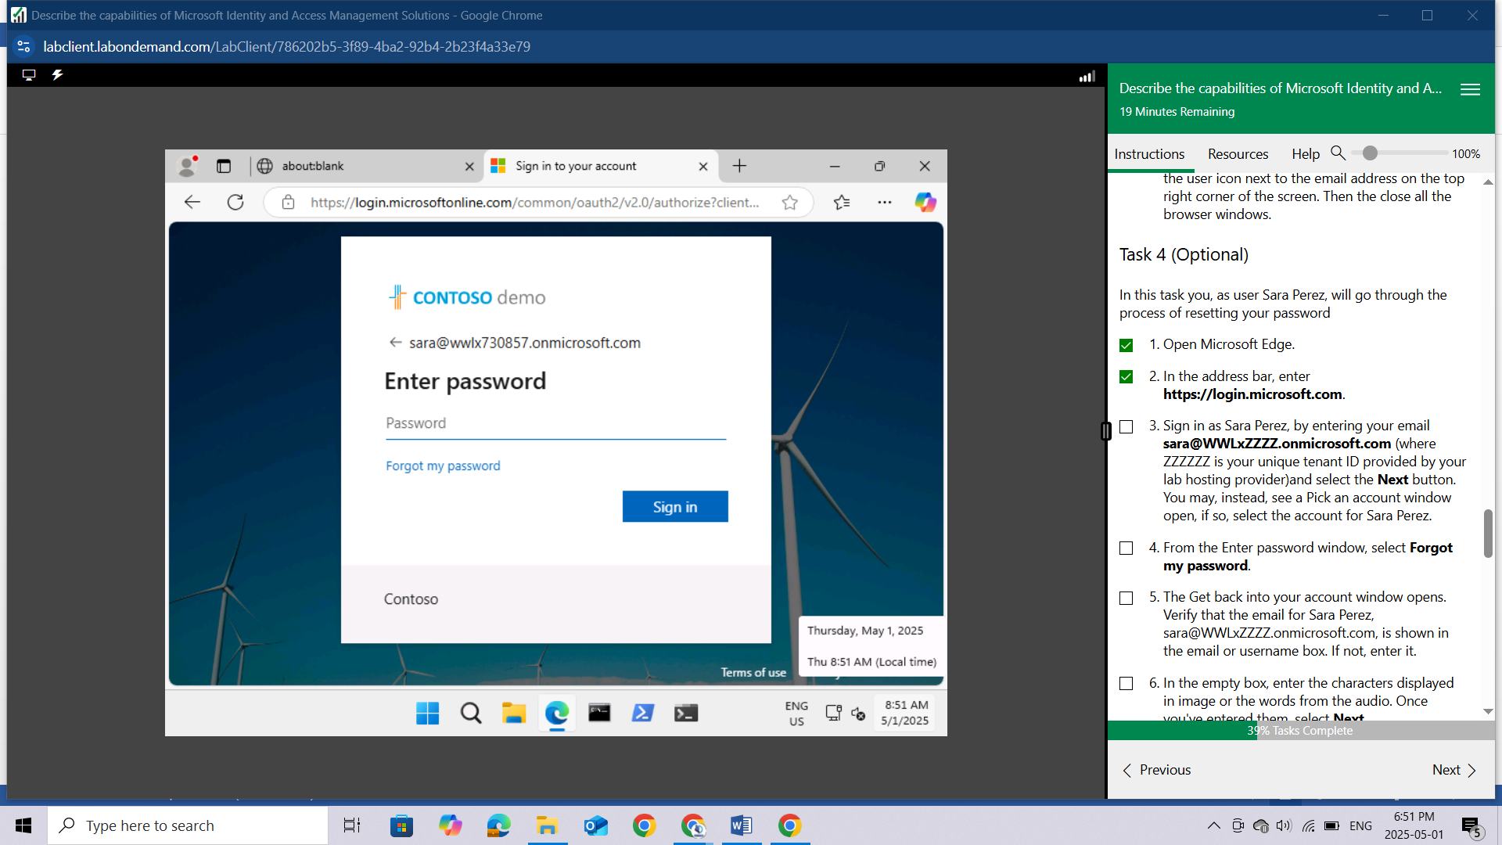

The Get back into your account window opens. Verify that the email for Sara Perez, sara@WWLxZZZZ.onmicrosoft.com, is shown in the email or username box. If not, enter it.

In the empty box, enter the characters displayed in image or the words from the audio. Once you've entered them, select **Next**.

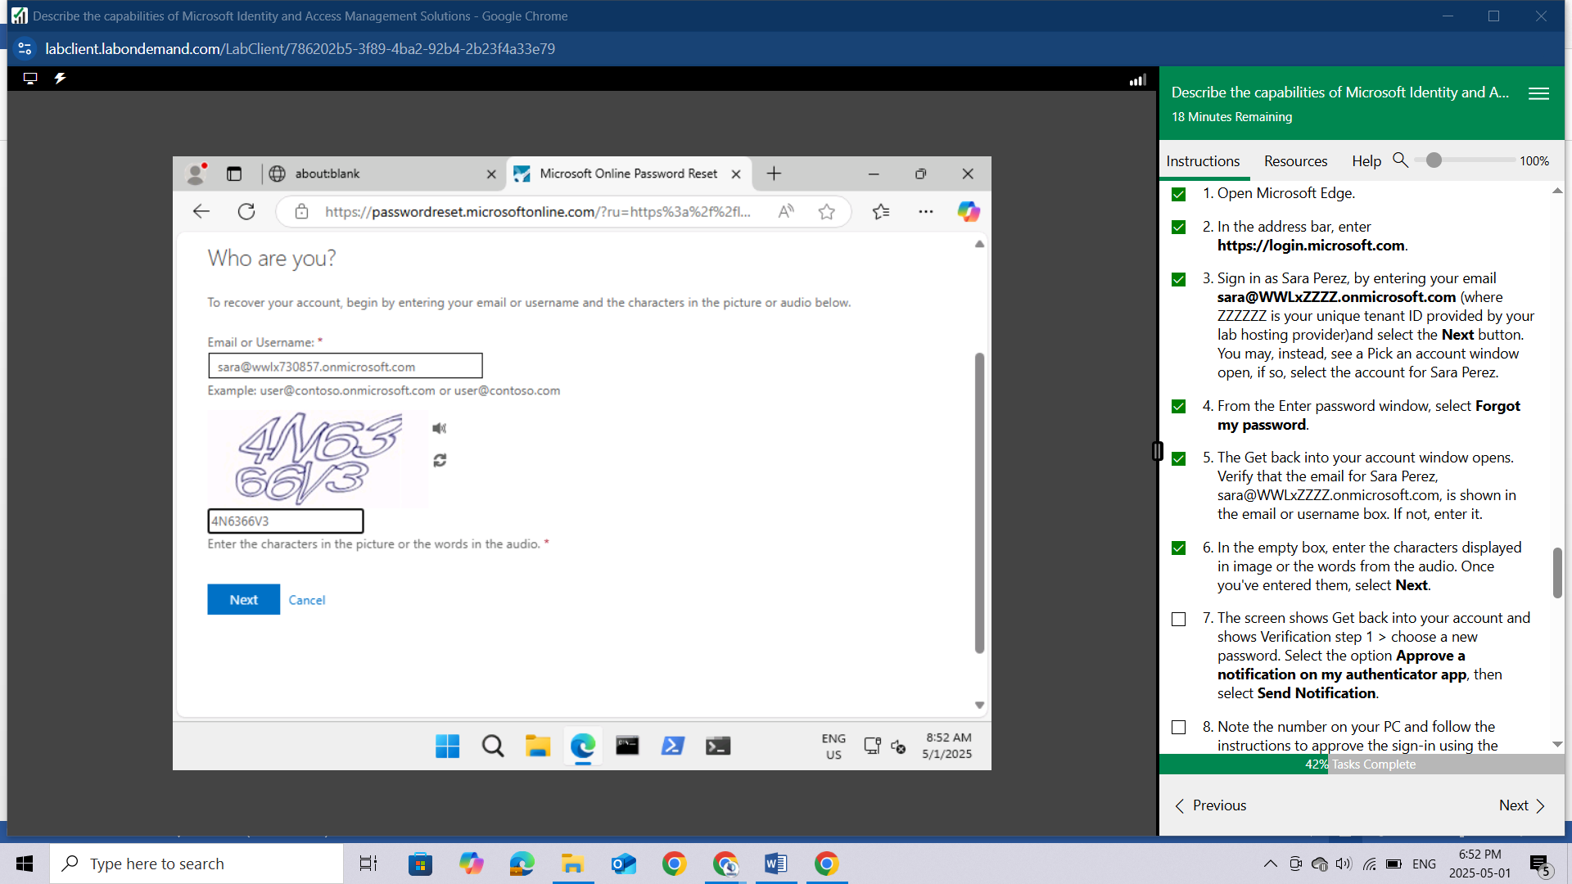

The screen shows Get back into your account and shows Verification step 1 > choose a new password. Select the option Approve a notification on my authenticator app, then select Send Notification.

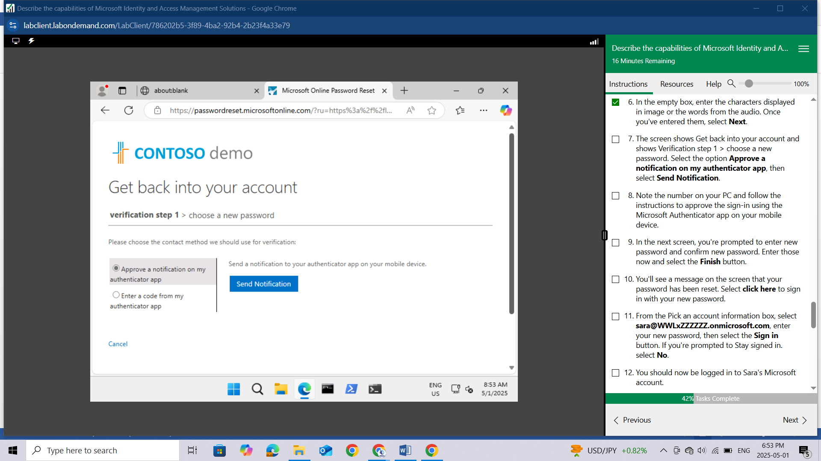

Note the number on your PC and follow the instructions to approve the sign-in using the Microsoft Authenticator app on your mobile device.

In the next screen, you're prompted to enter new password and confirm new password. Enter those now and select the Finish button.

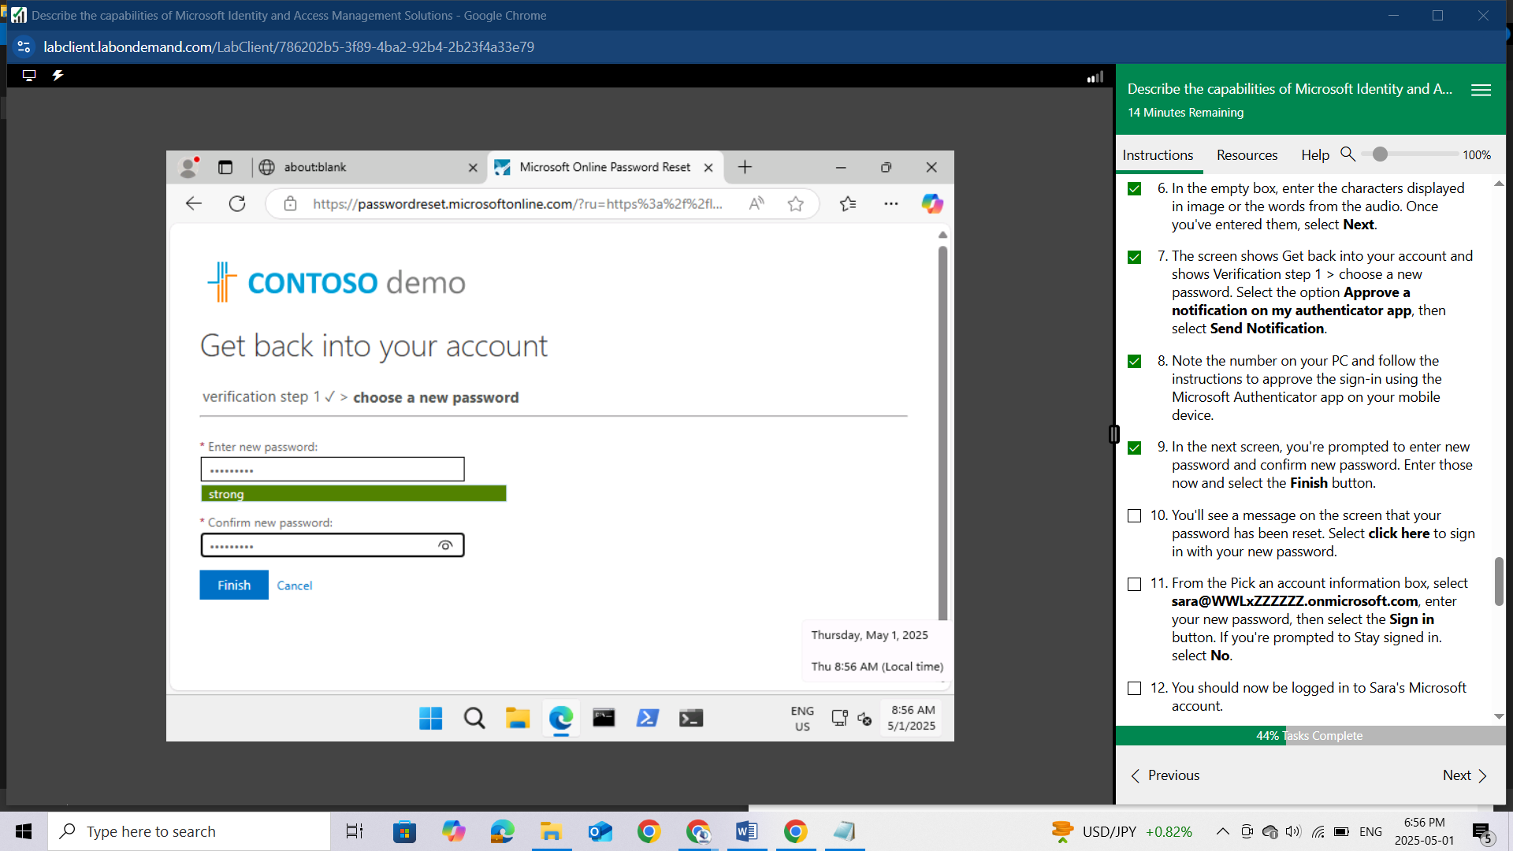

You'll see a message on the screen that your password has been reset. Select **click here** to sign in with your new password.

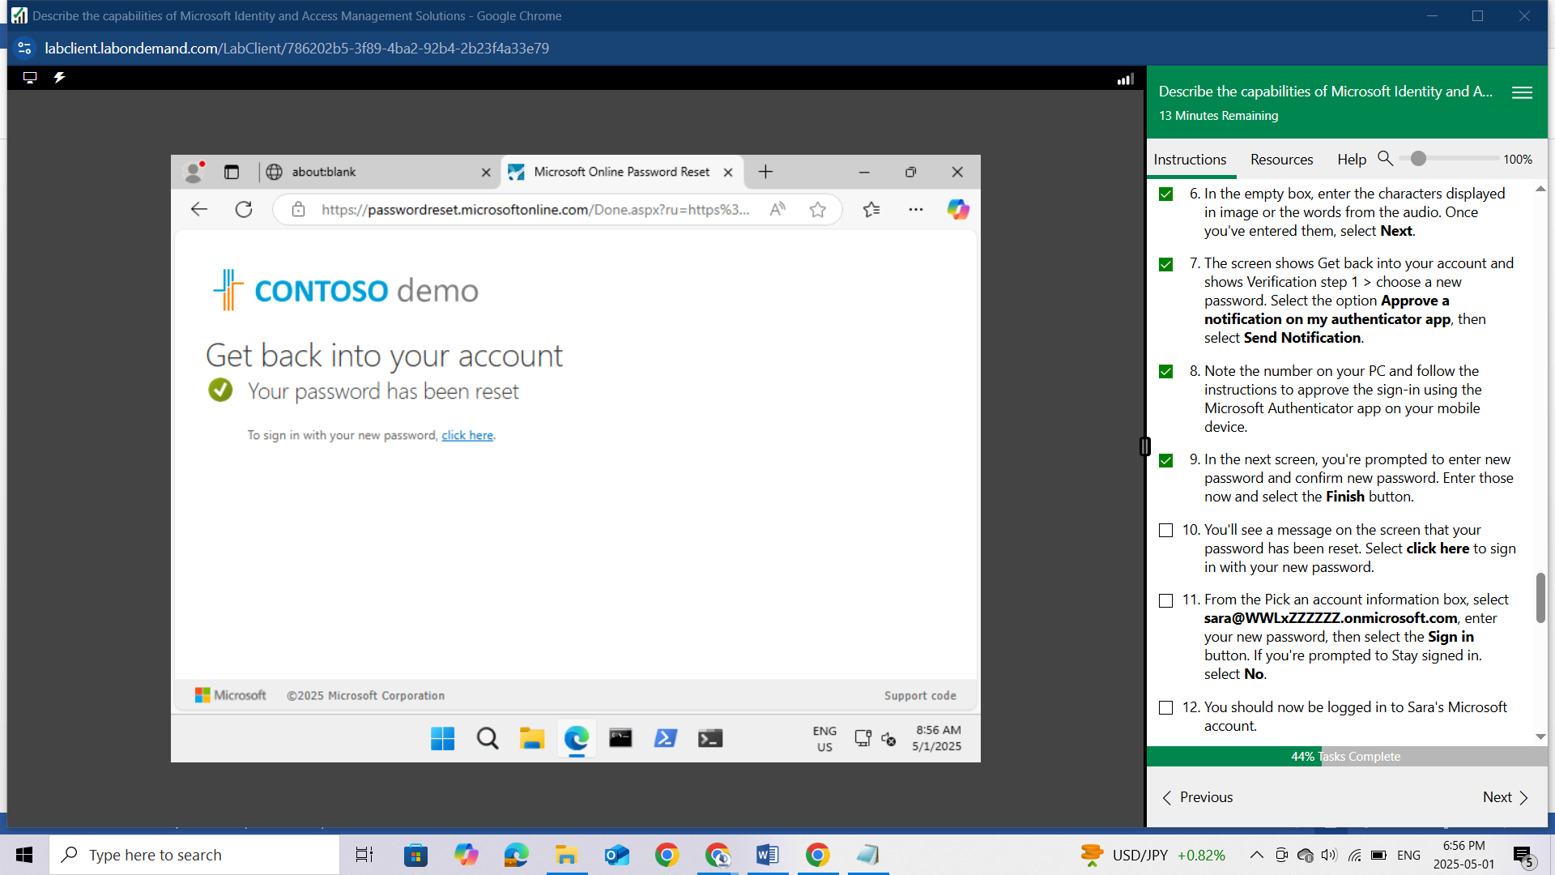

From the Pick an account information box, select sara@WWLxZZZZZZ.onmicrosoft.com, enter your new password, then select the Sign in button.

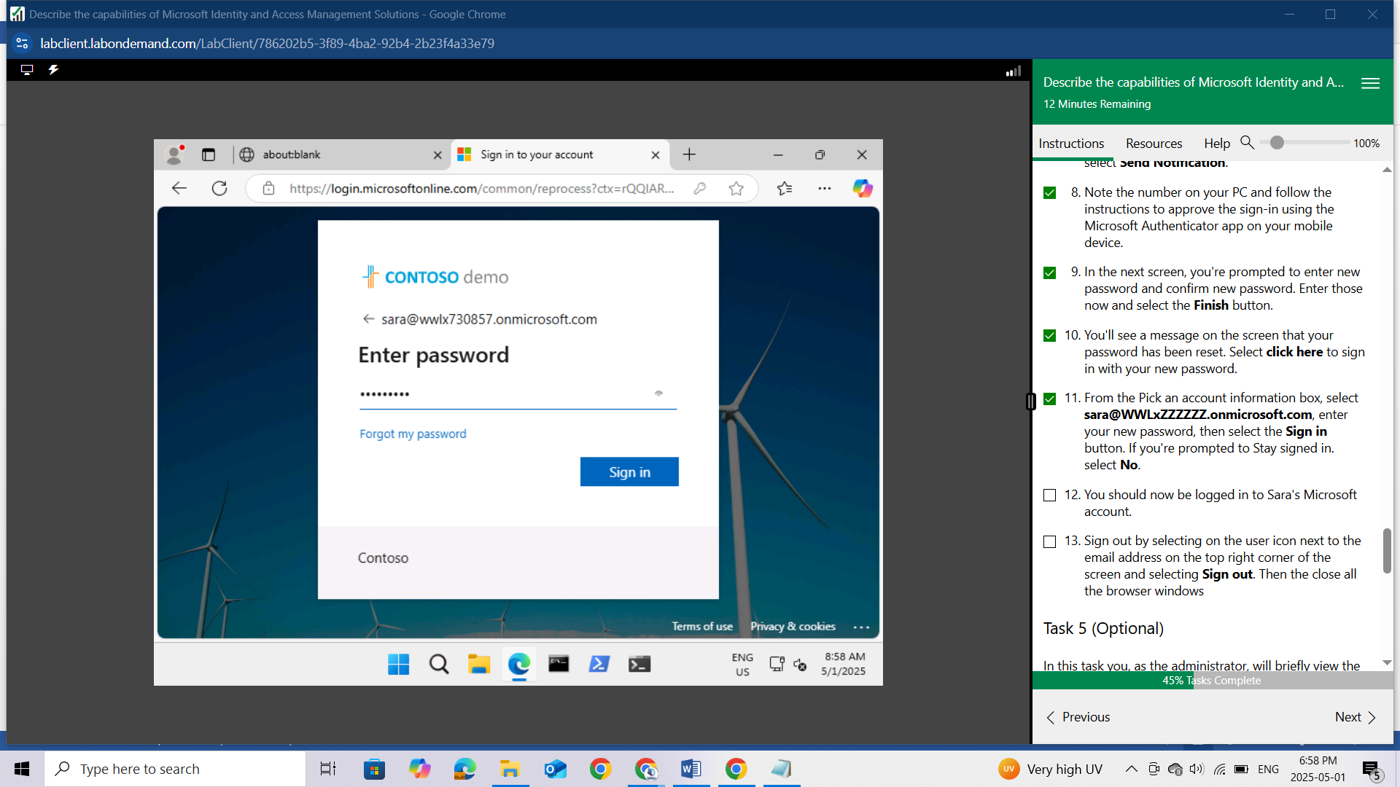

If you're prompted to Stay signed in. select No.

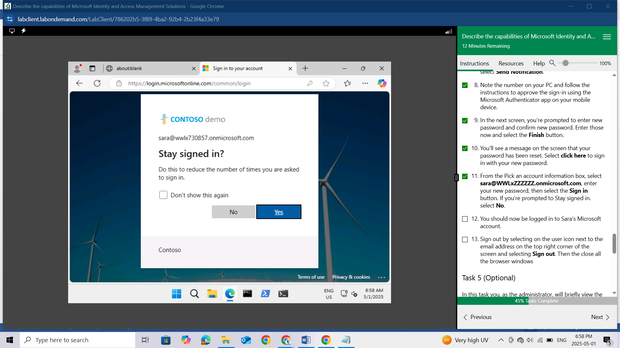

You should now be logged in to Sara's Microsoft account.

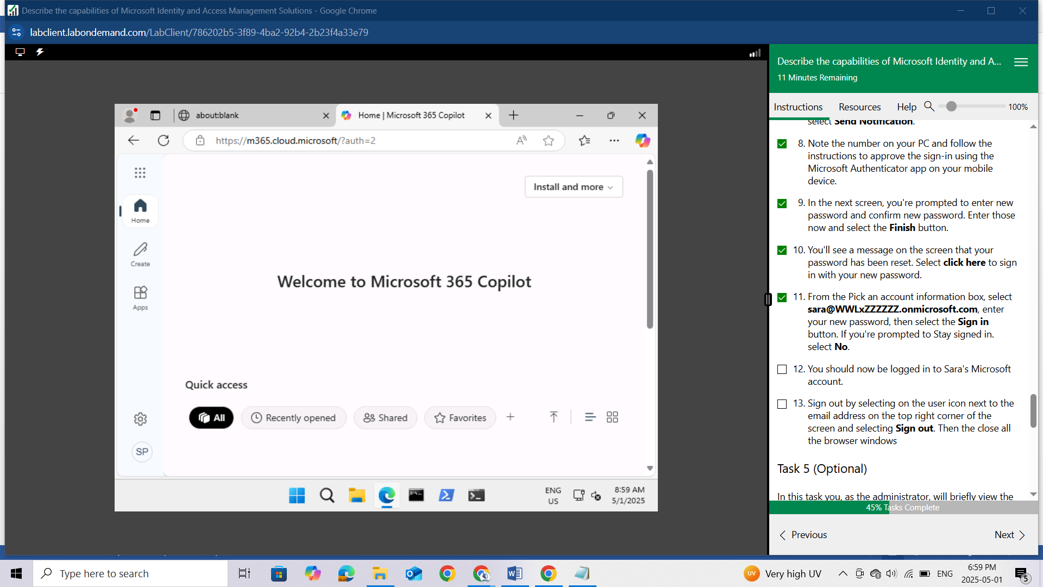

Sign out by selecting on the user icon next to the email address on the top right corner of the screen and selecting Sign out. Then the close all the browser windows

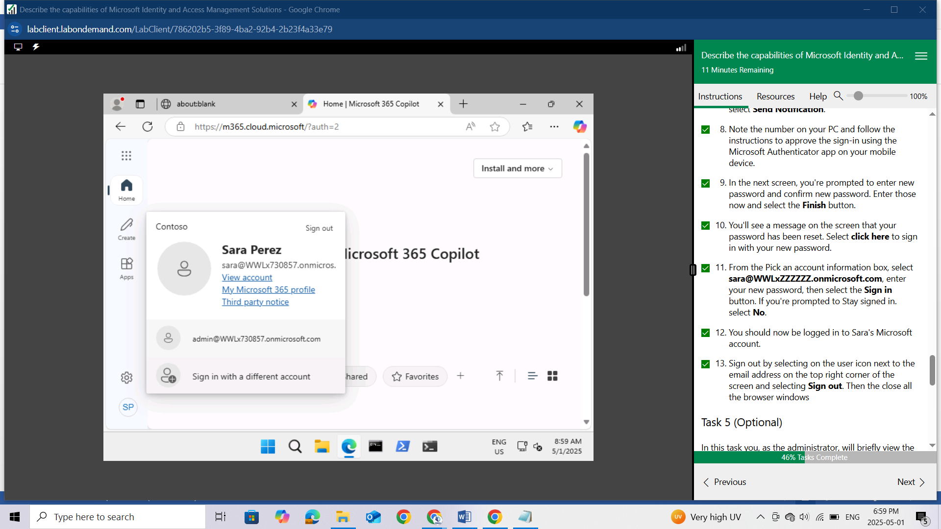

## Task 5 (Optional)

In this task you, as the administrator, will briefly view the Audit logs and the Usage & insights data associated with password reset

Open Microsoft Edge.

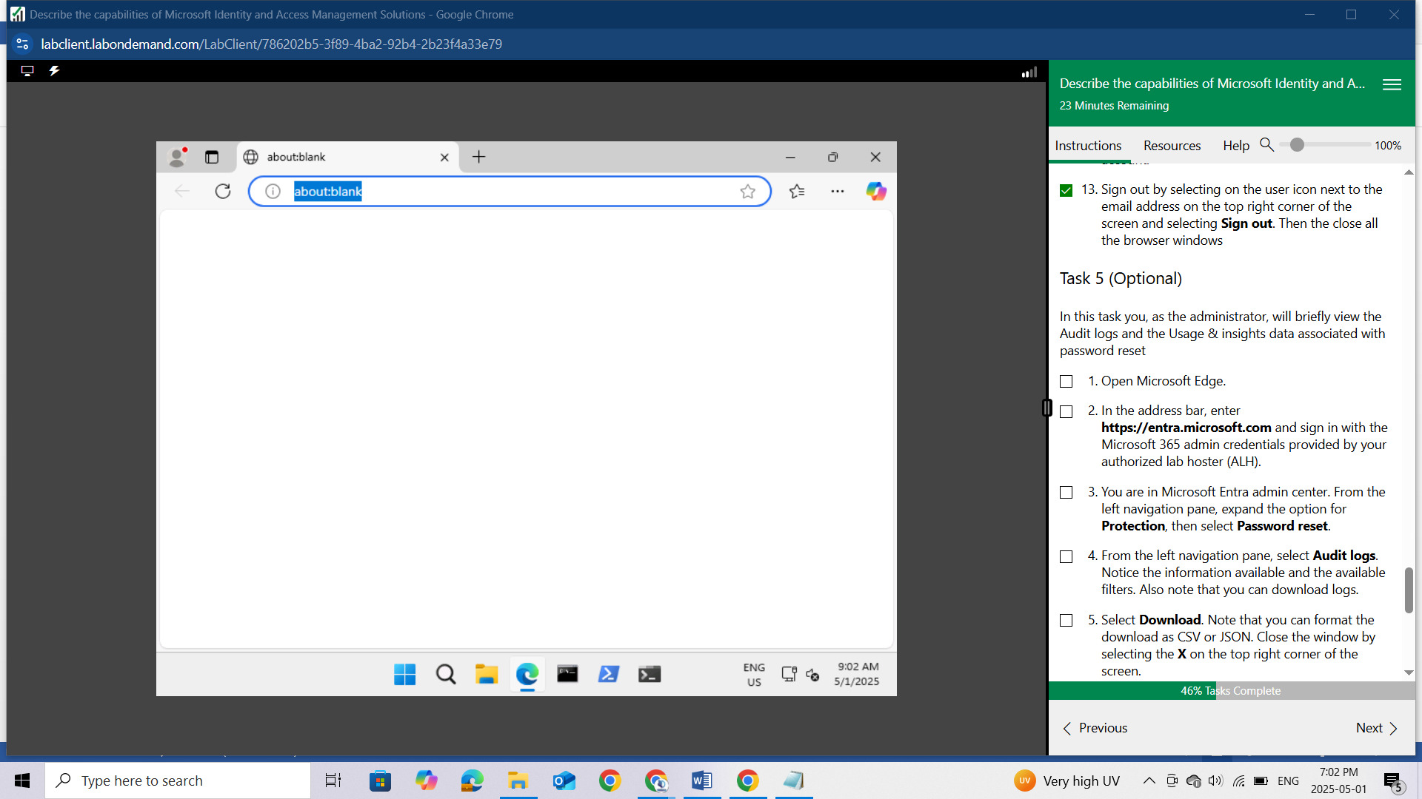

In the address bar, enter https://entra.microsoft.com and sign in with the Microsoft 365 admin credentials provided by your authorized lab hoster (ALH).

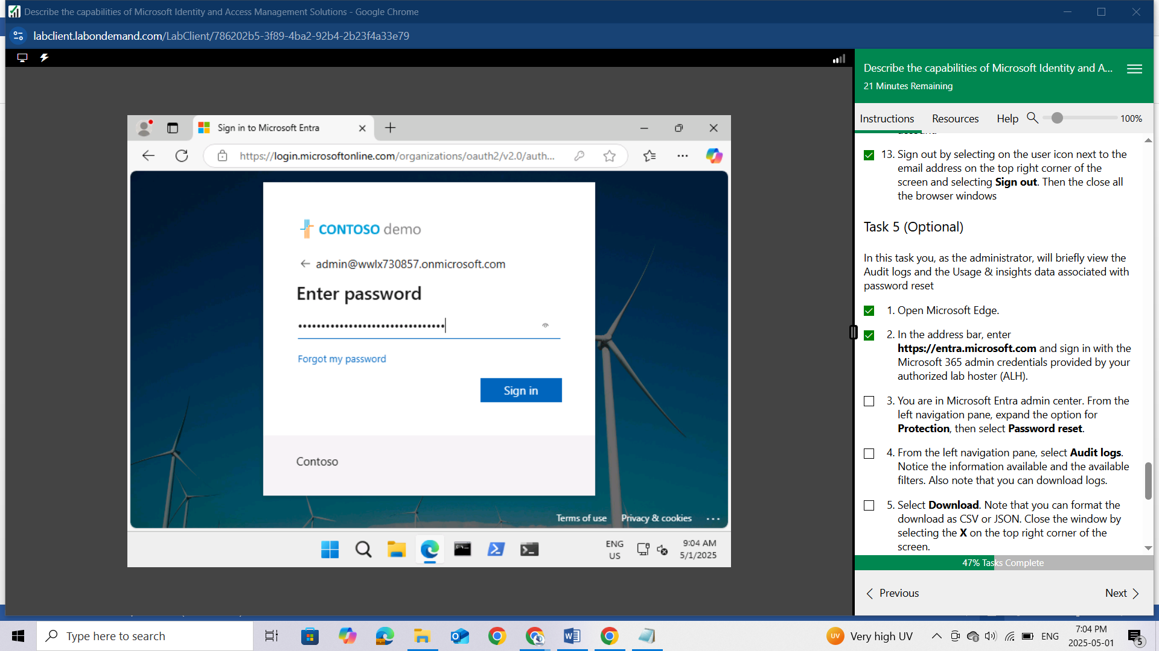

You are in Microsoft Entra admin center. From the left navigation pane, expand the option for Protection, then select Password reset.

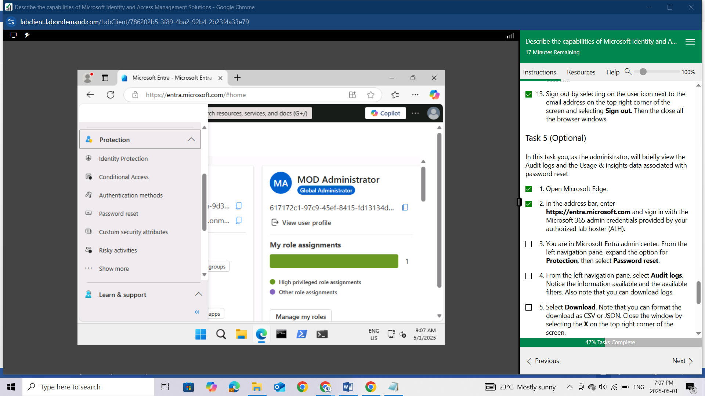

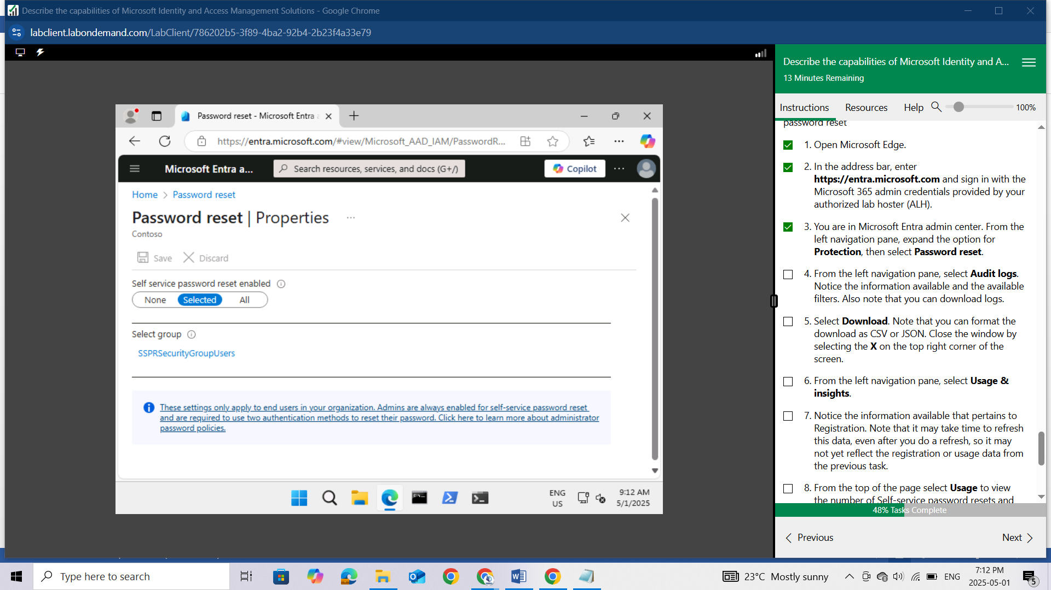

From the left navigation pane, select Audit logs.

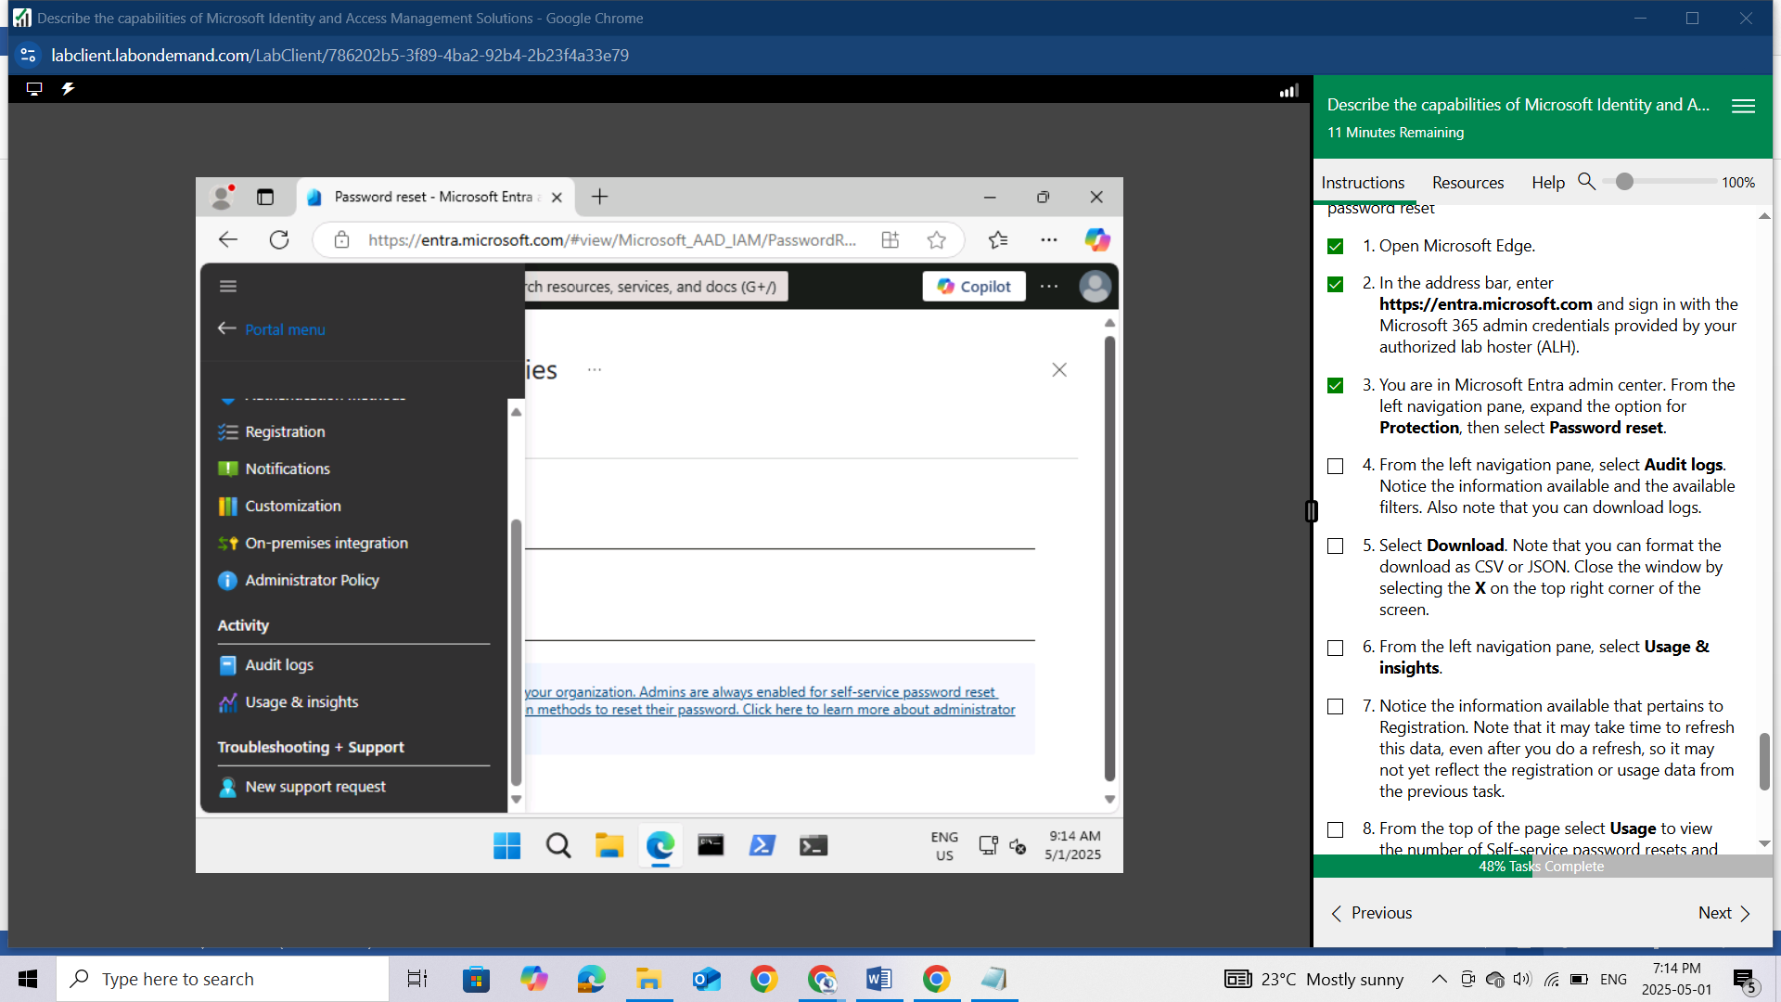

Notice the information available and the available filters. Also note that you can download logs.

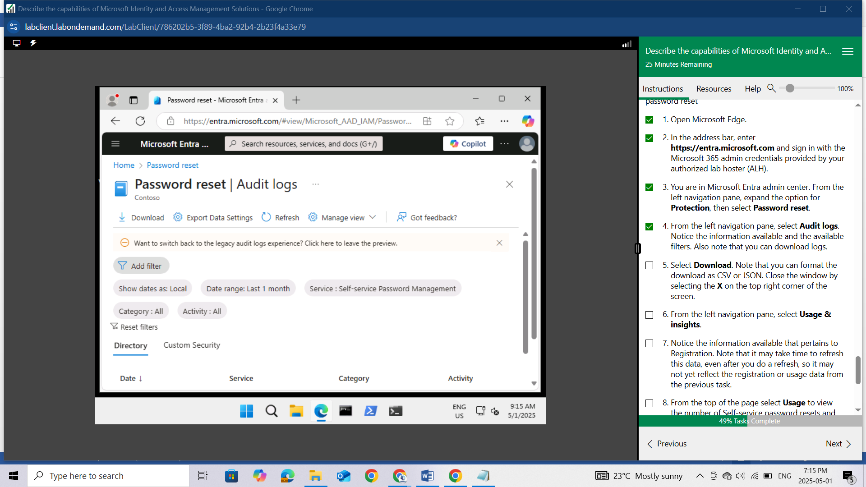

Select Download. Note that you can format the download as CSV or JSON. Close the window by selecting the X on the top right corner of the screen.

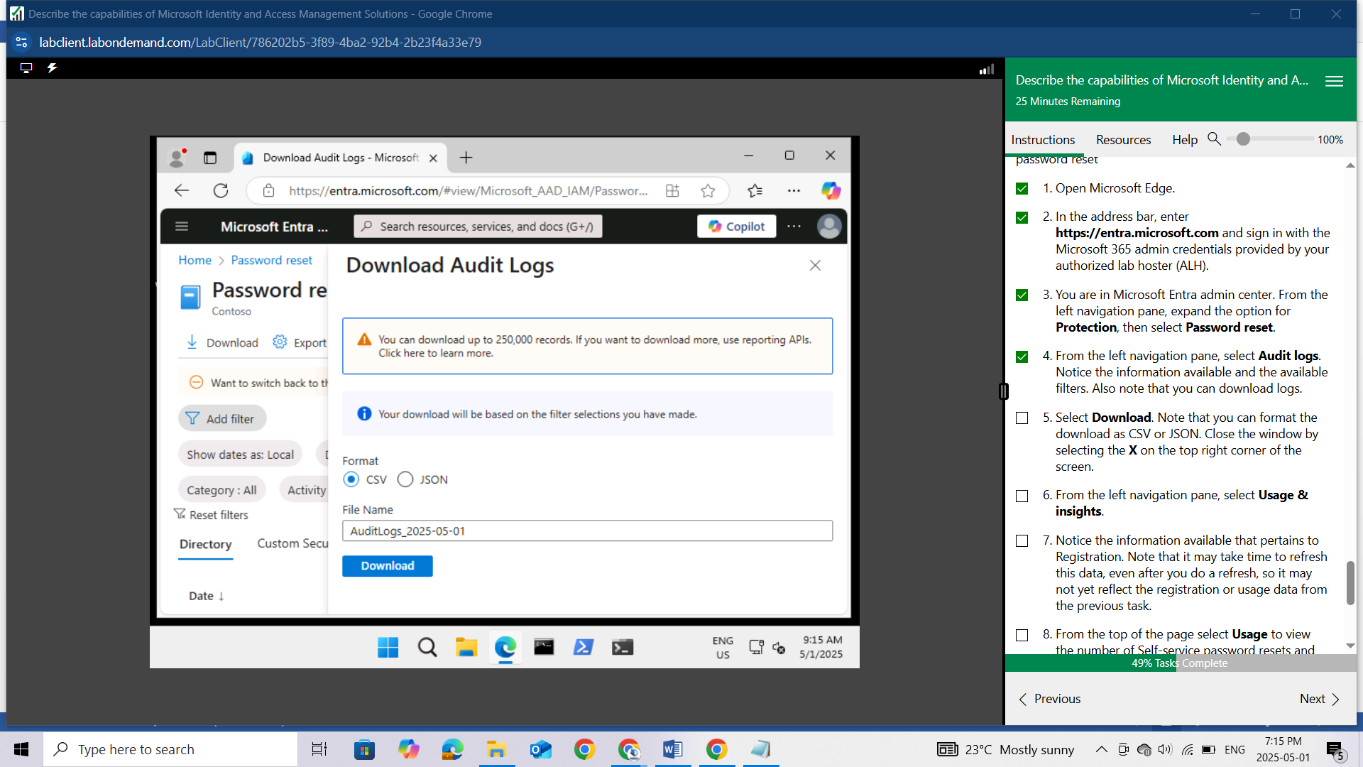

From the left navigation pane, select Usage & insights.

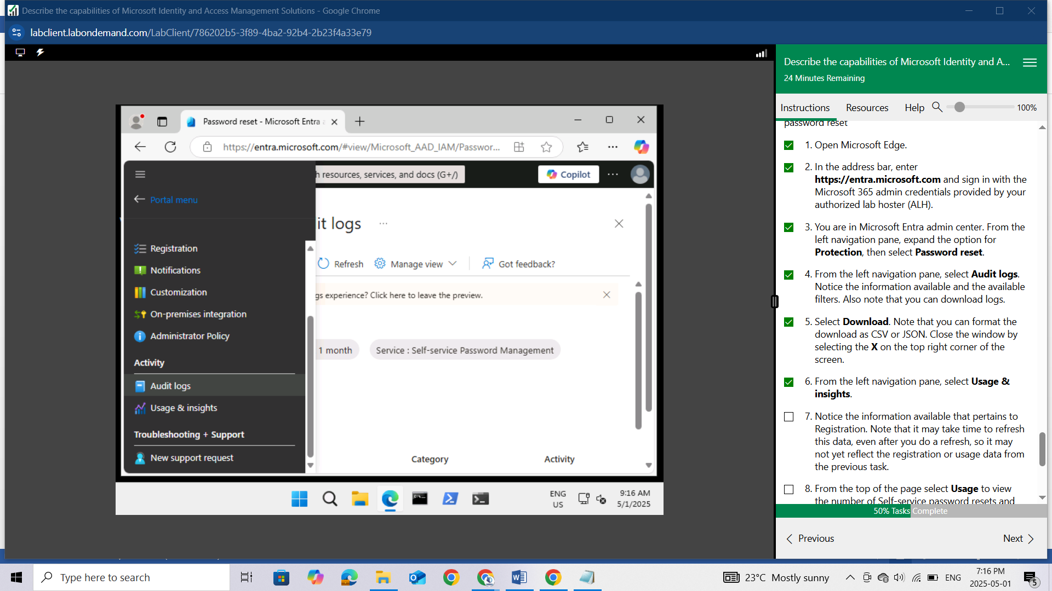

Notice the information available that pertains to Registration. Note that it may take time to refresh this data, even after you do a refresh, so it may not yet reflect the registration or usage data from the previous task.

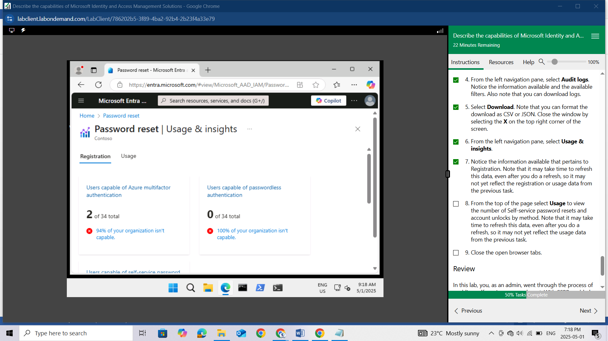

From the top of the page select **Usage** to view the number of Self-service password resets and account unlocks by method. Note that it may take time to refresh this data, even after you do a refresh, so it may not yet reflect the usage data from the previous task.

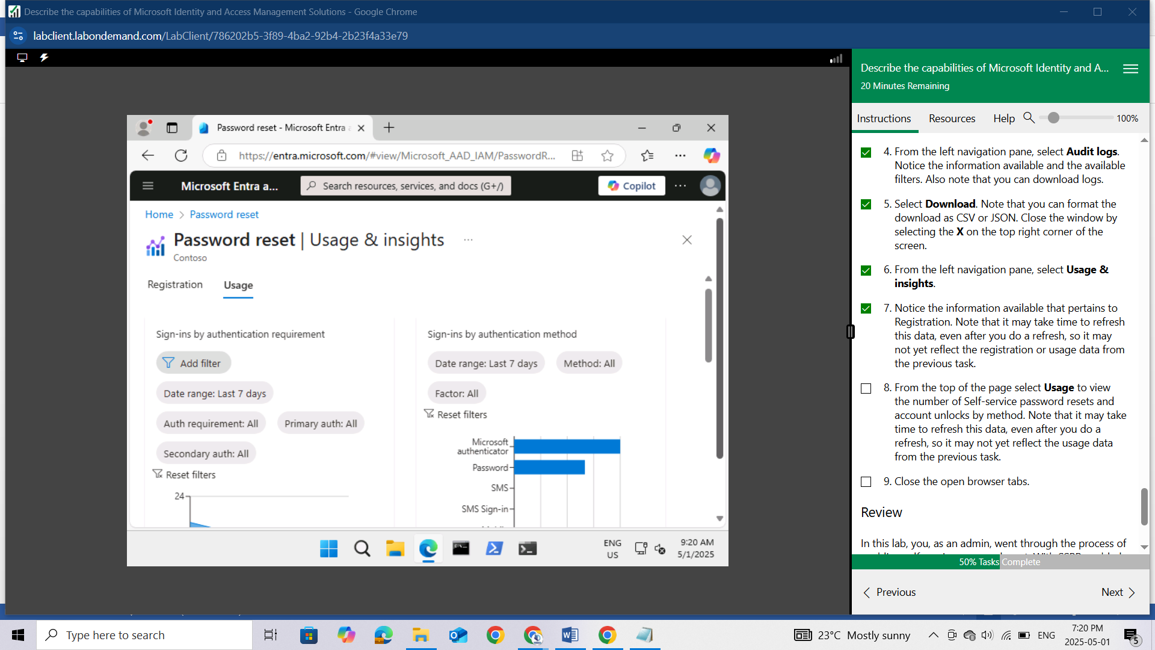

Close the open browser tabs.

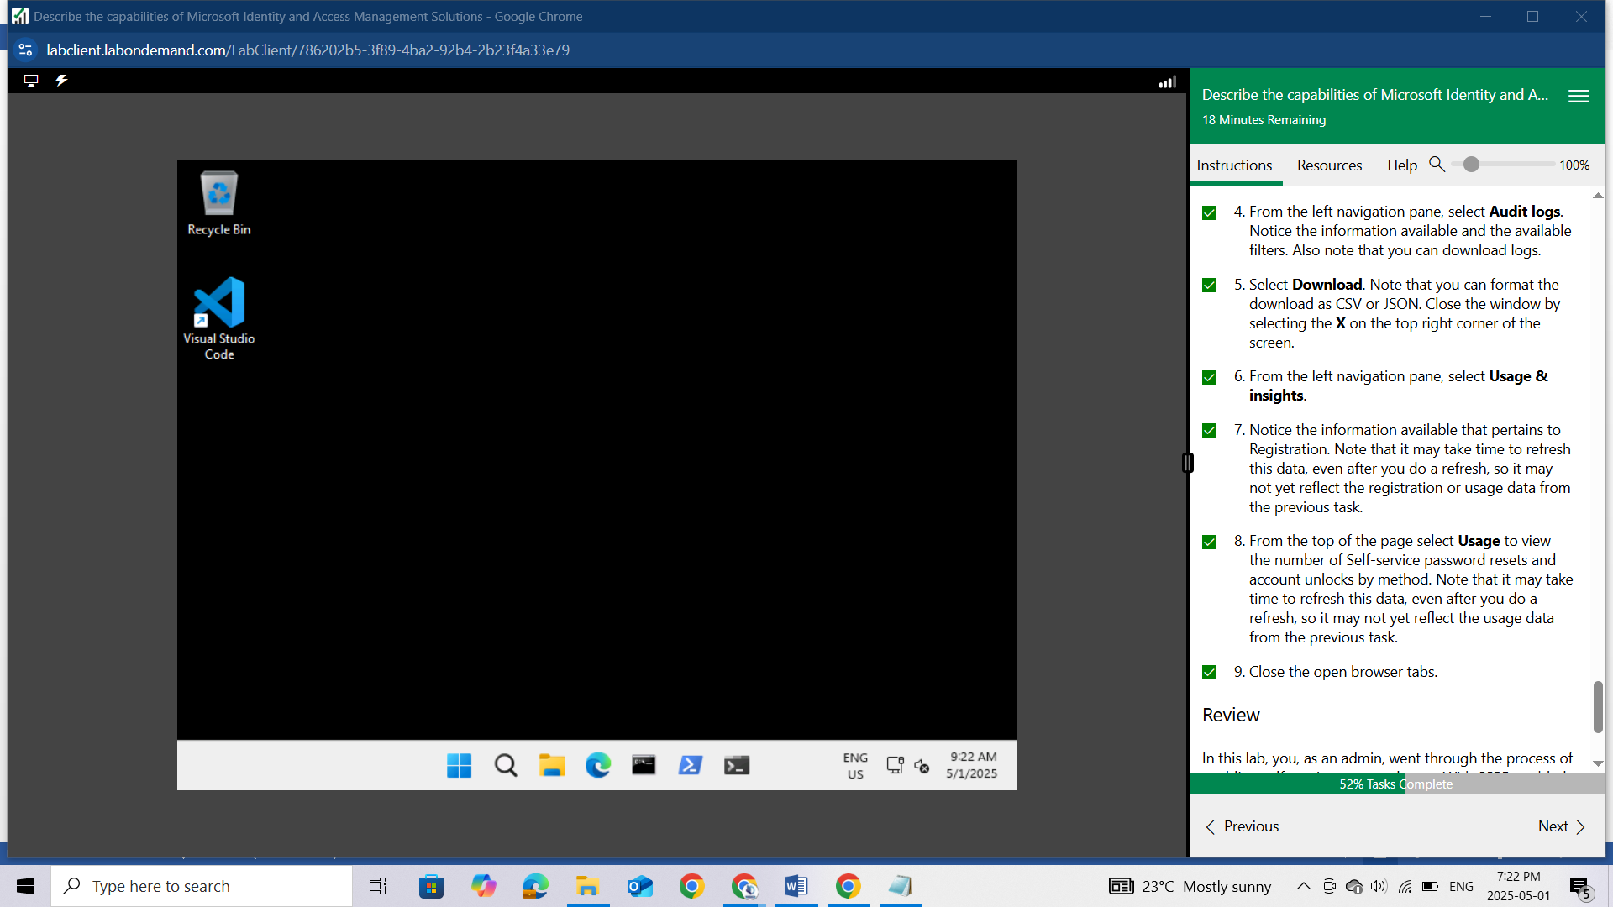

## Review

In this lab, you, as an admin, went through the process of enabling self-service password reset. With SSPR enabled, you'll then assume the role of a user to go through the process of registering for SSPR and also resetting your password. Lastly, you as the admin, learn where to access audit logs and usage & insights data for SSPR.

# Lab: Microsoft Entra Conditional Access

This lab maps to the following Learn content:

* Learning Path: Describe the capabilities of Microsoft Entra
* Module: Describe access management capabilities of Microsoft Entra
* Unit: Describe Conditional Access

# Lab scenario

In this lab, you'll explore conditional access MFA, from the perspective of an admin and a user. As the admin, you will create a policy that will require a user to go through multi-factor authentication when accessing any of the Microsoft Admin portals. From a user perspective, you'll see the impact of the conditional access policy, including the process to register for MFA.

## Task 1

In this task you, as the admin, will reset the password for the user Debra Berger. This step is needed so you can initially sign in as the user in subsequent tasks.

Open Microsoft Edge. In the address bar, enter https://entra.microsoft.com, and sign in with your admin credentials.

In the Sign-in window, enter admin@WWLx730857.onmicrosoft.com (where ZZZZZZ is your unique tenant ID provided by your lab hosting provider) then select Next.

Enter the admin password that should be provided by your lab hosting provider. Select Sign in.

Depending on your lab hoster and if this is the first time you are logging in to the tenant, you may be prompted to complete the MFA registration process. If so, follow the prompts on the screen to setup MFA.

Once you're signed-in, you're taken to the Microsoft 365 admin center page.

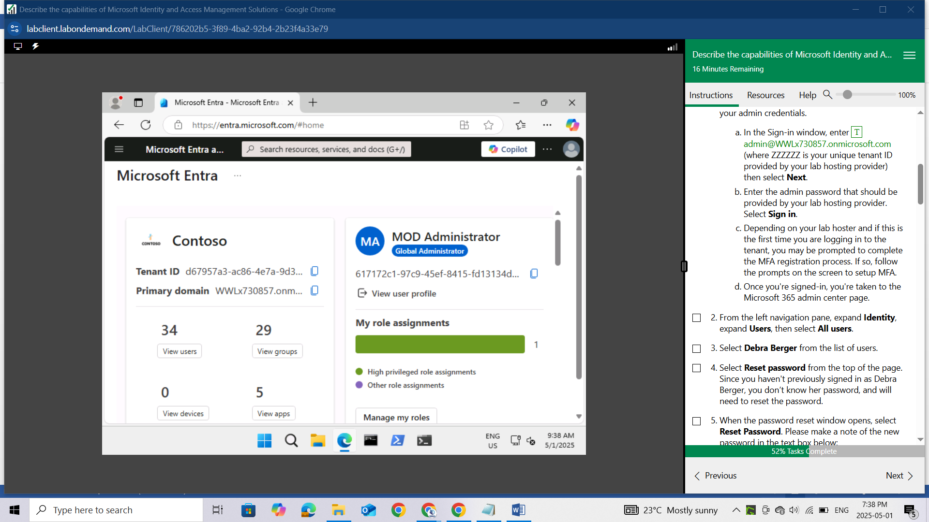

From the left navigation pane, expand Identity, expand Users, then select All users.

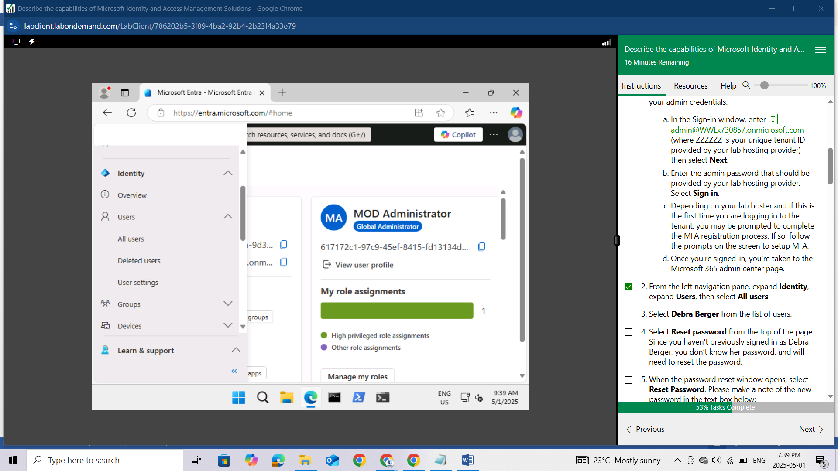

Select Debra Berger from the list of users.

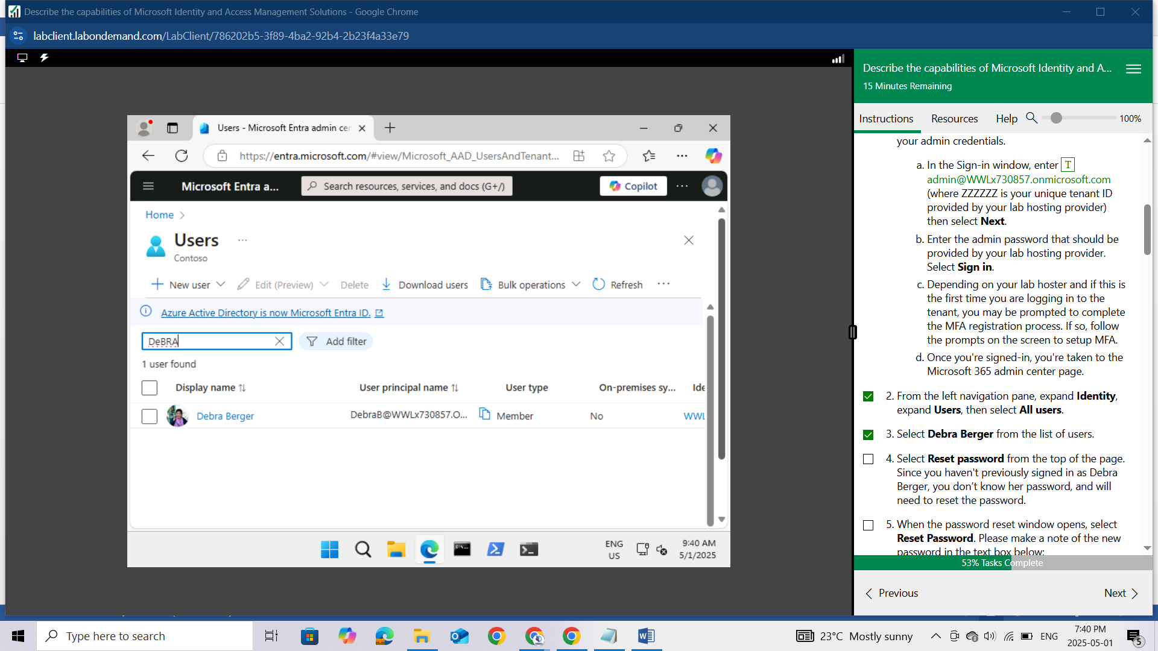

Select Reset password from the top of the page. Since you haven't previously signed in as Debra Berger, you don’t know her password, and will need to reset the password.

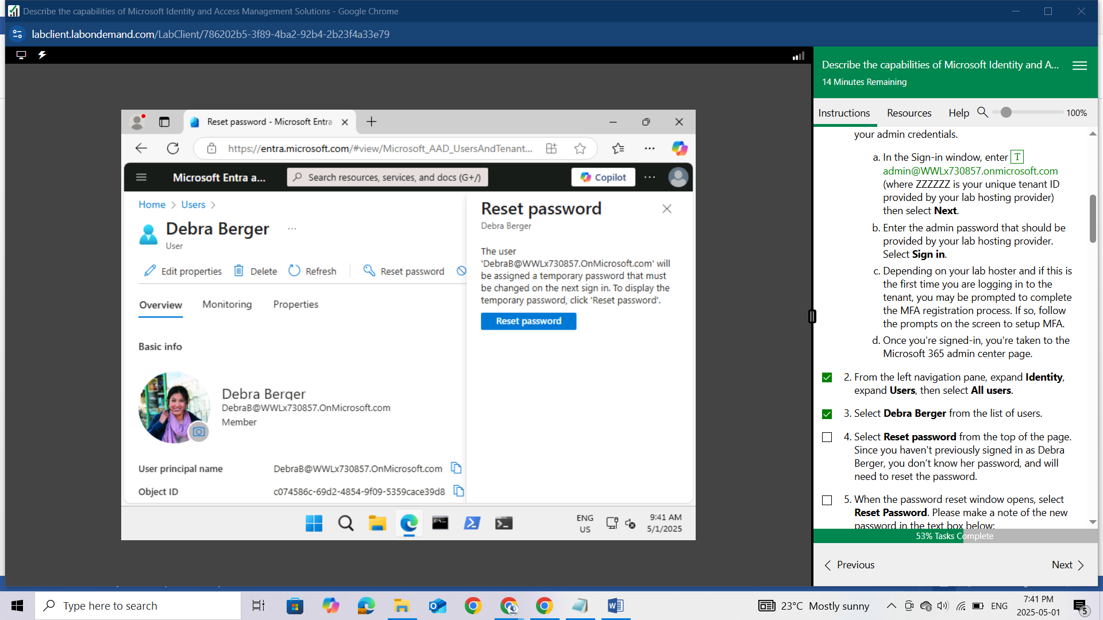

When the password reset window opens, select Reset Password. Please make a note of the new password in the text box below:

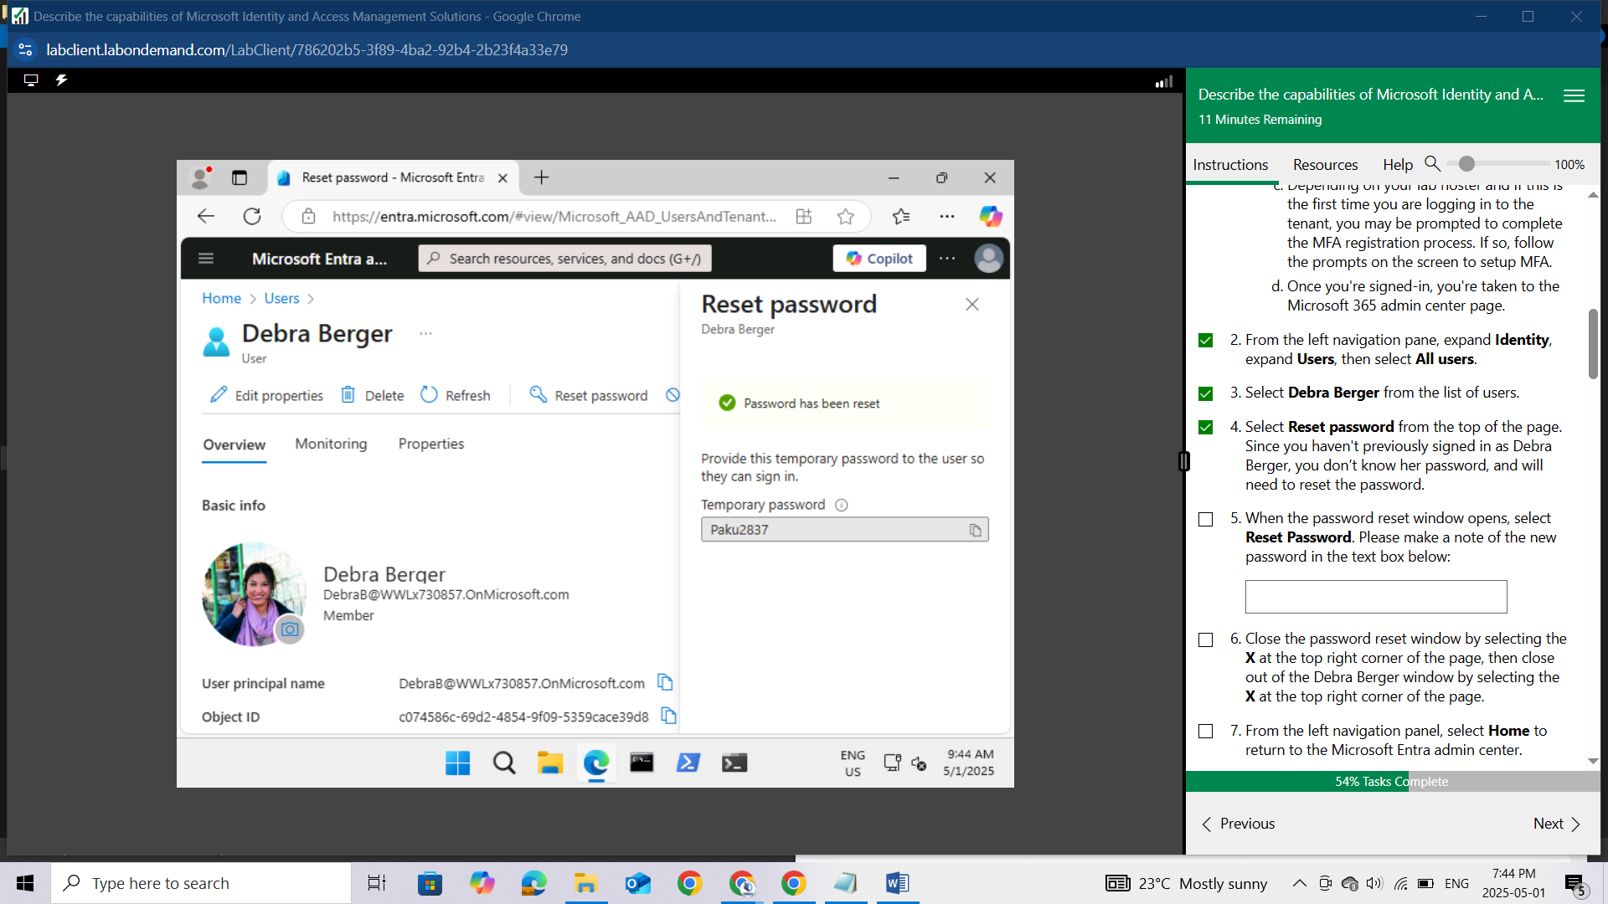

Close the password reset window by selecting the X at the top right corner of the page, then close out of the Debra Berger window by selecting the X at the top right corner of the page.

From the left navigation panel, select Home to return to the Microsoft Entra admin center.

Keep this window open.

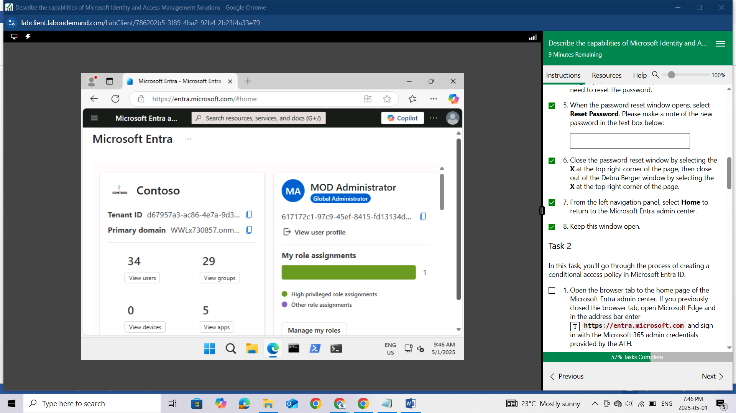

## Task 2

In this task, you'll go through the process of creating a conditional access policy in Microsoft Entra ID.

Open the browser tab to the home page of the Microsoft Entra admin center. If you previously closed the browser tab, open Microsoft Edge and in the address bar enter https://entra.microsoft.com and sign in with the Microsoft 365 admin credentials provided by the ALH.

From the left navigation pane, expand Protection then select Conditional Access.

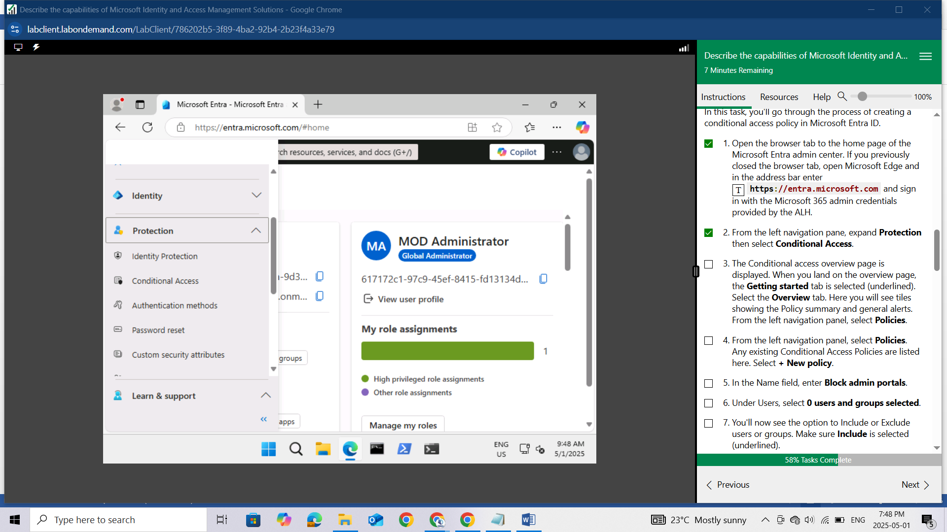

The Conditional access overview page is displayed. When you land on the overview page, the Getting started tab is selected (underlined). Select the Overview tab. Here you will see tiles showing the Policy summary and general alerts.

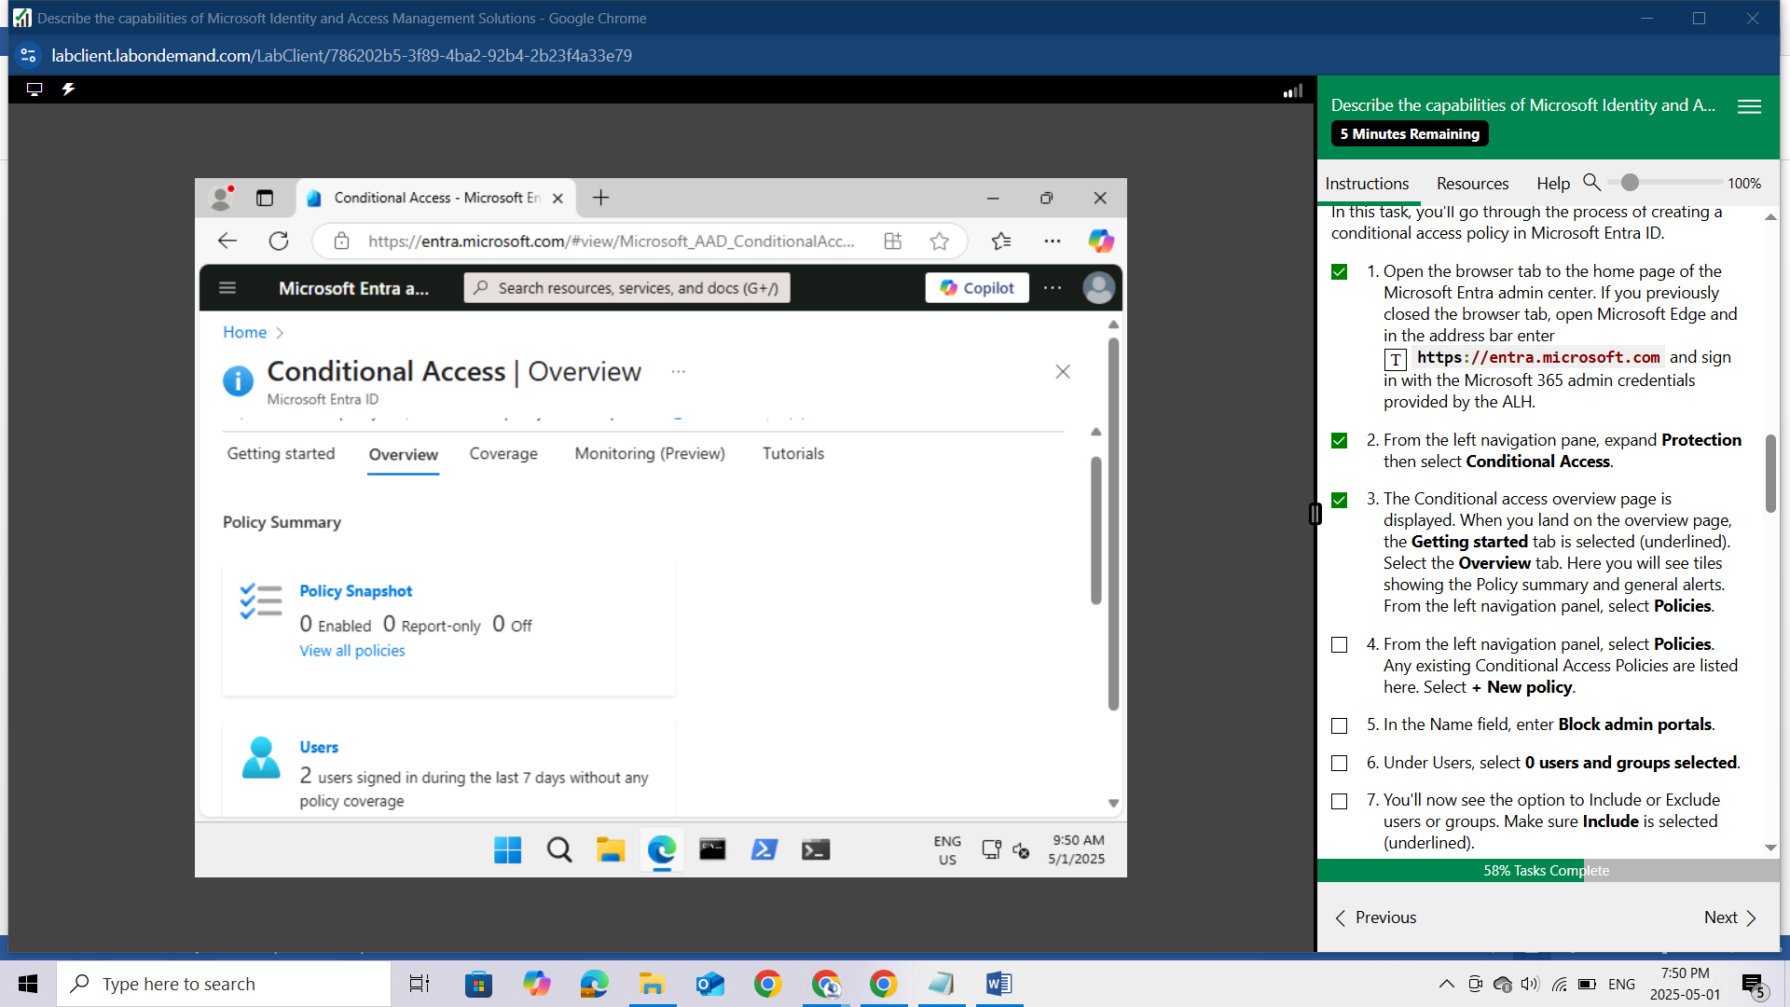

From the left navigation panel, select Policies.

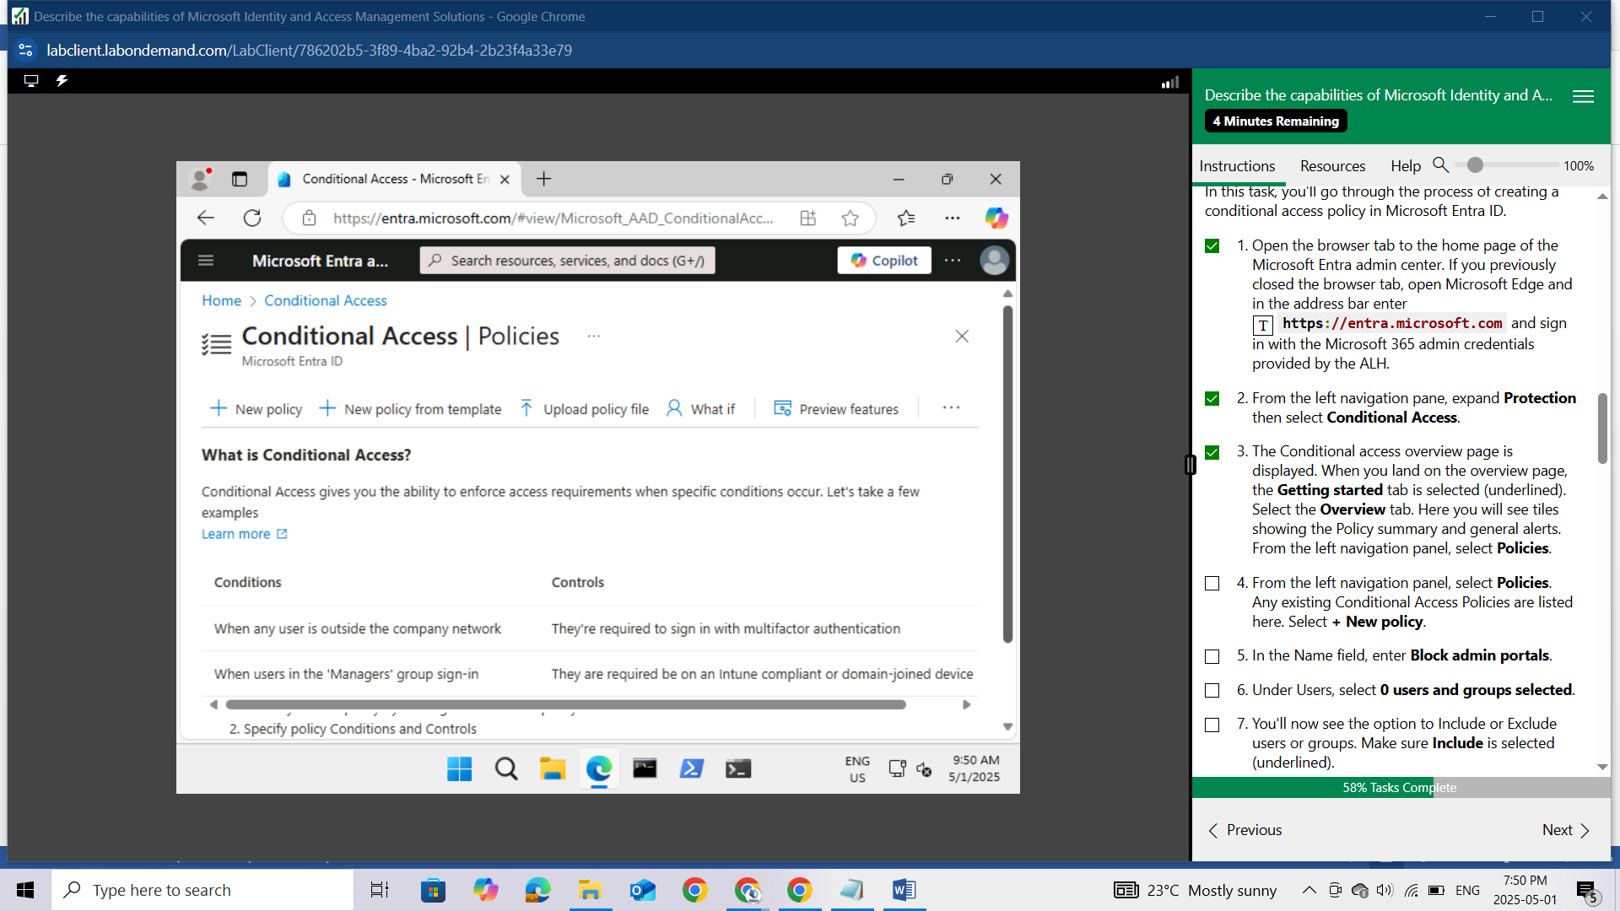

Any existing Conditional Access Policies are listed here. Select + New policy.

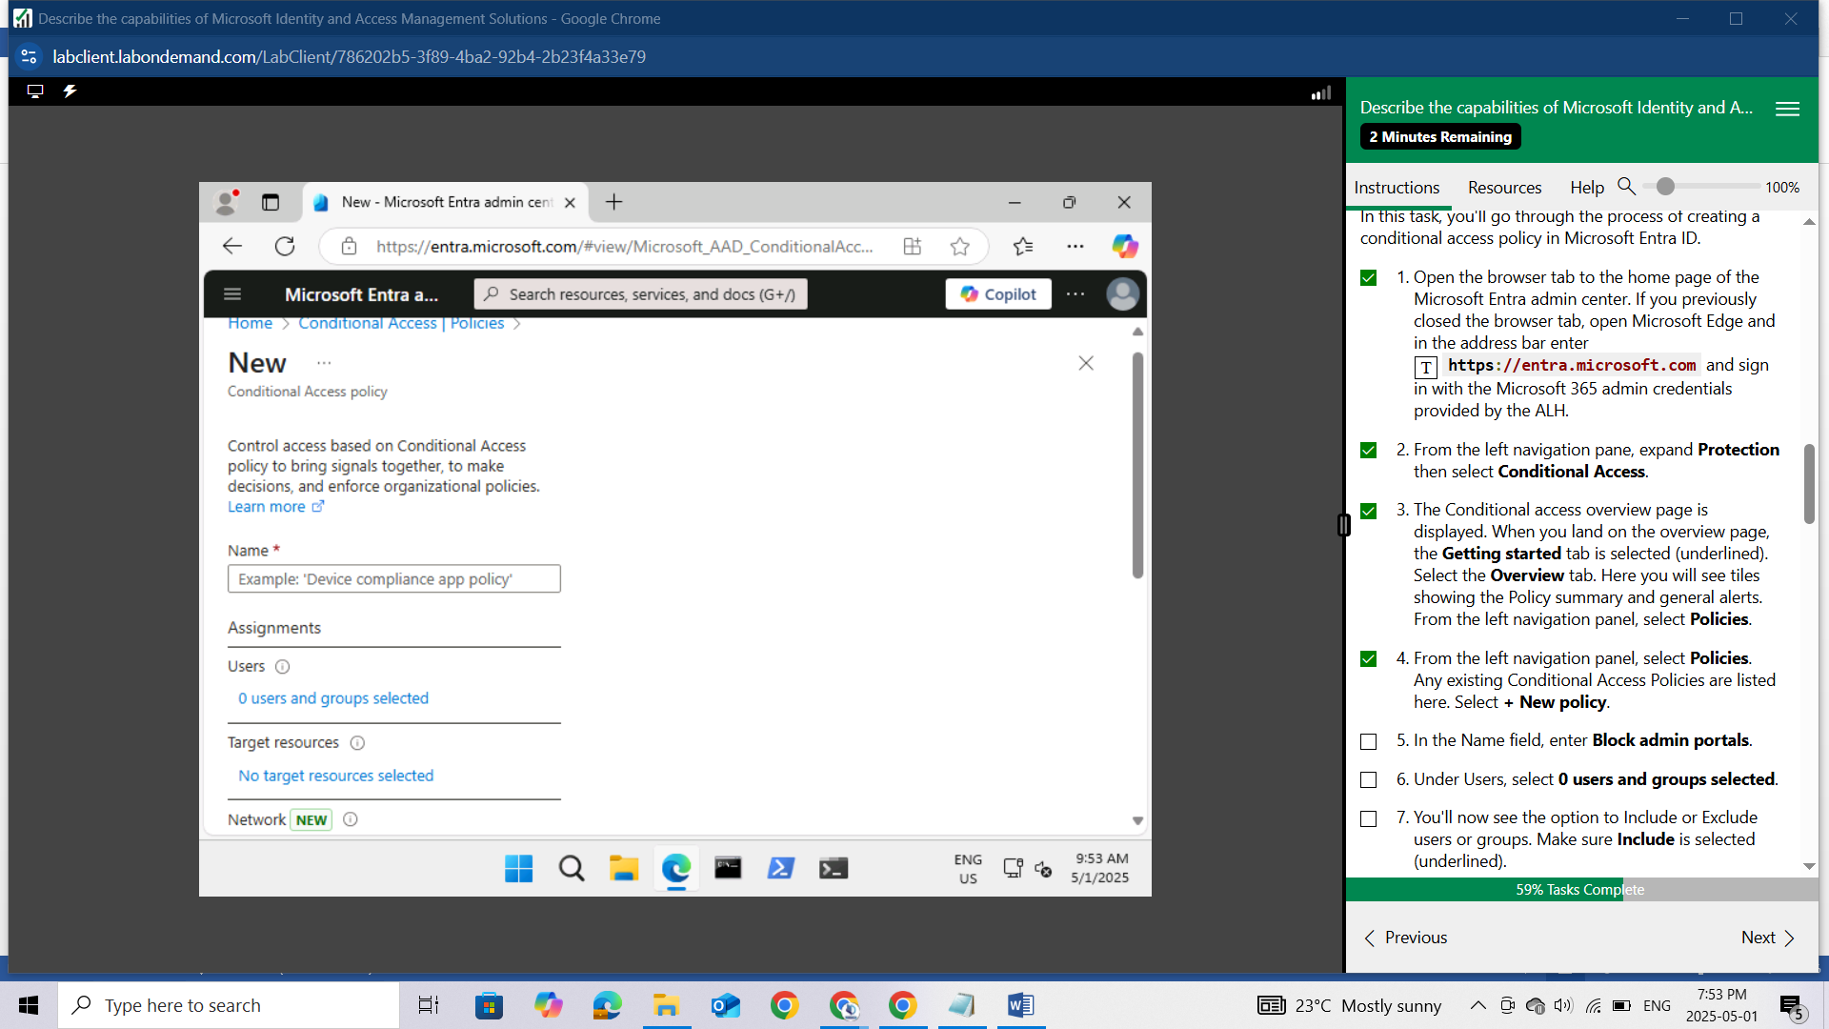

In the Name field, enter Block admin portals.

Under Users, select 0 users and groups selected.

You'll now see the option to Include or Exclude users or groups. Make sure Include is selected (underlined).

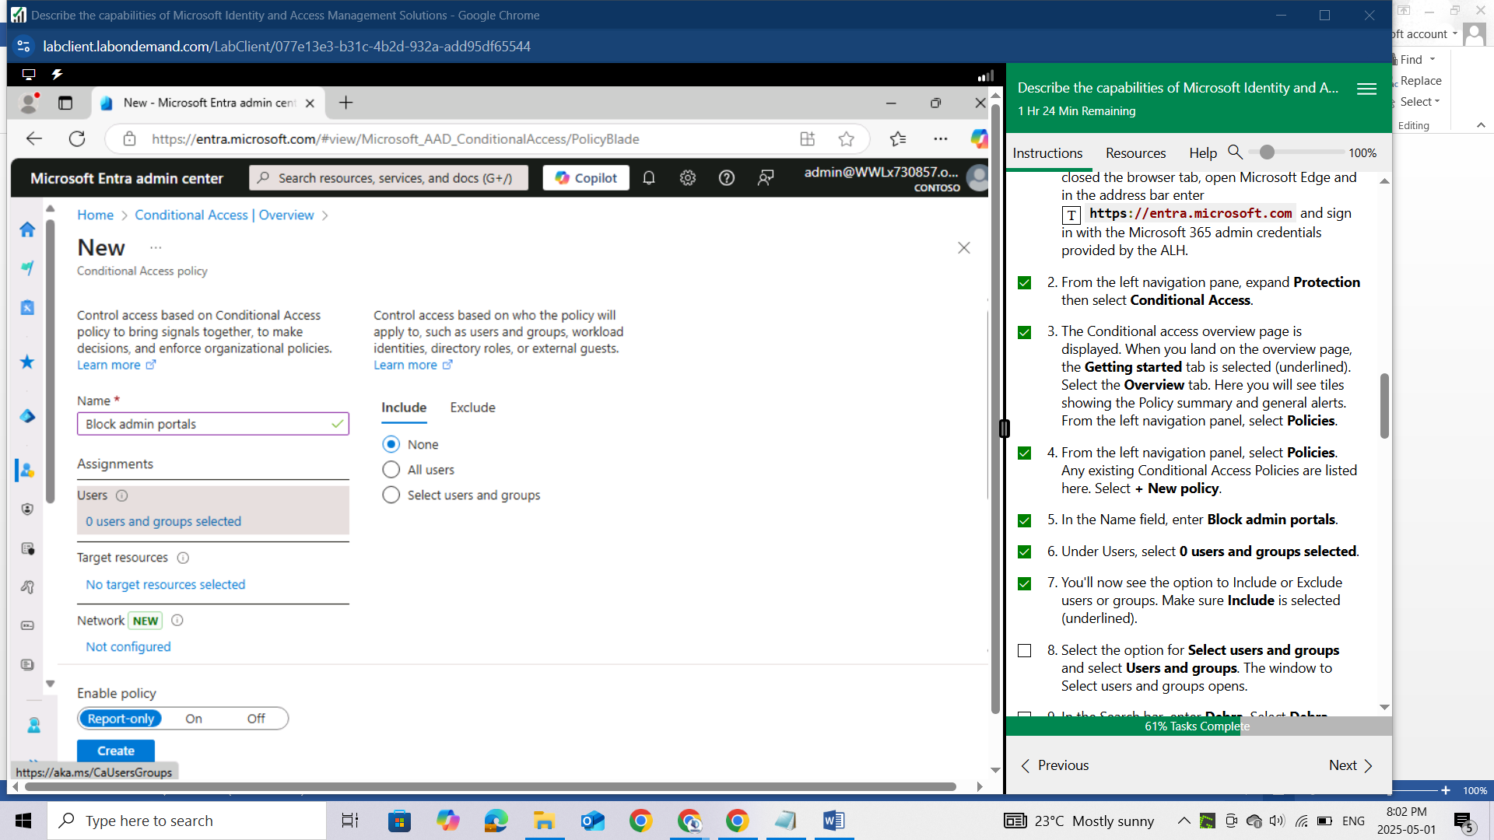

Select the option for Select users and groups and select Users and groups. The window to Select users and groups opens.

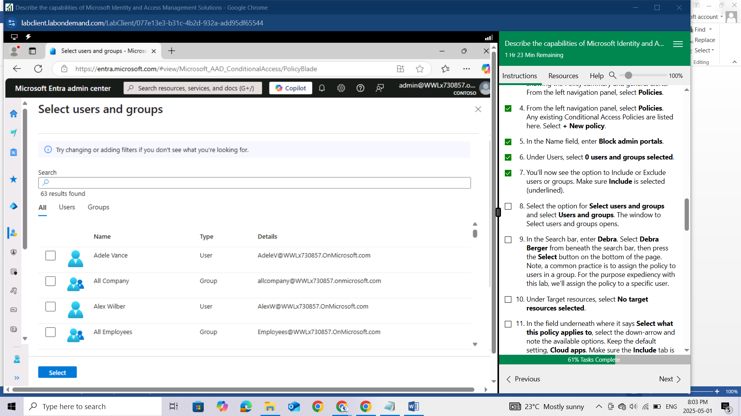In the Search bar, enter Debra. Select Debra Berger from beneath the search bar, then press the **Select** button on the bottom of the page. Note, a common practice is to assign the policy to users in a group. For the purpose expediency with this lab, we'll assign the policy to a specific user.

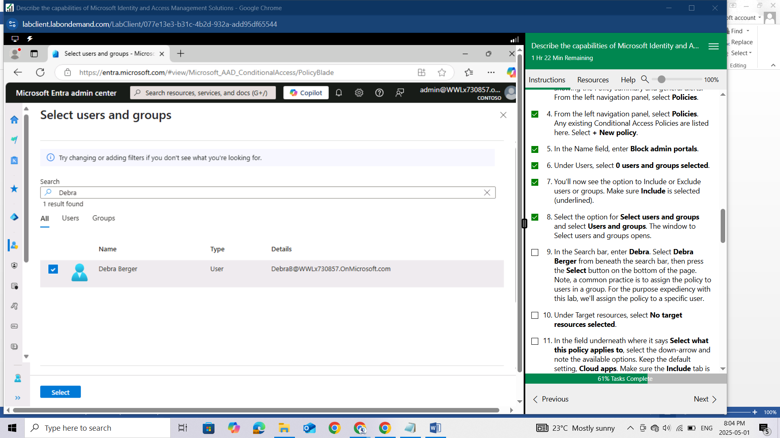

Under Target resources, select No target resources selected.

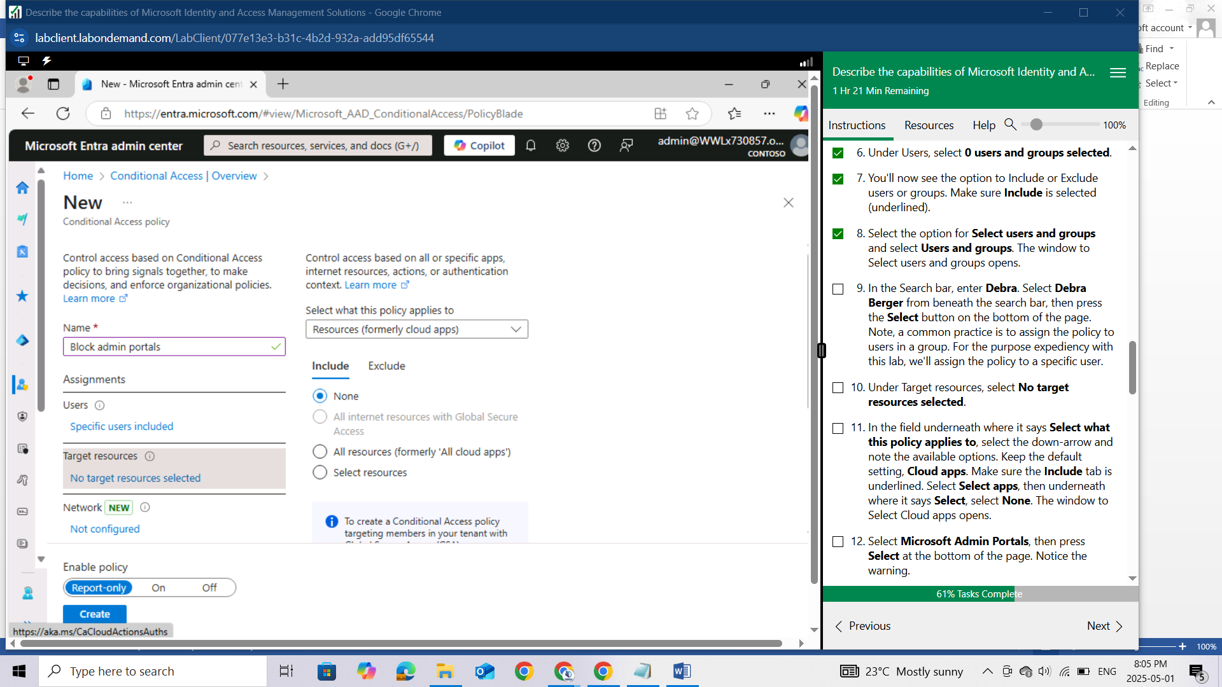

In the field underneath where it says Select what this policy applies to, select the down-arrow and note the available options. Keep the default setting, Cloud apps. Make sure the Include tab is underlined. Select Select apps, then underneath where it says Select, select None. The window to Select Cloud apps opens.

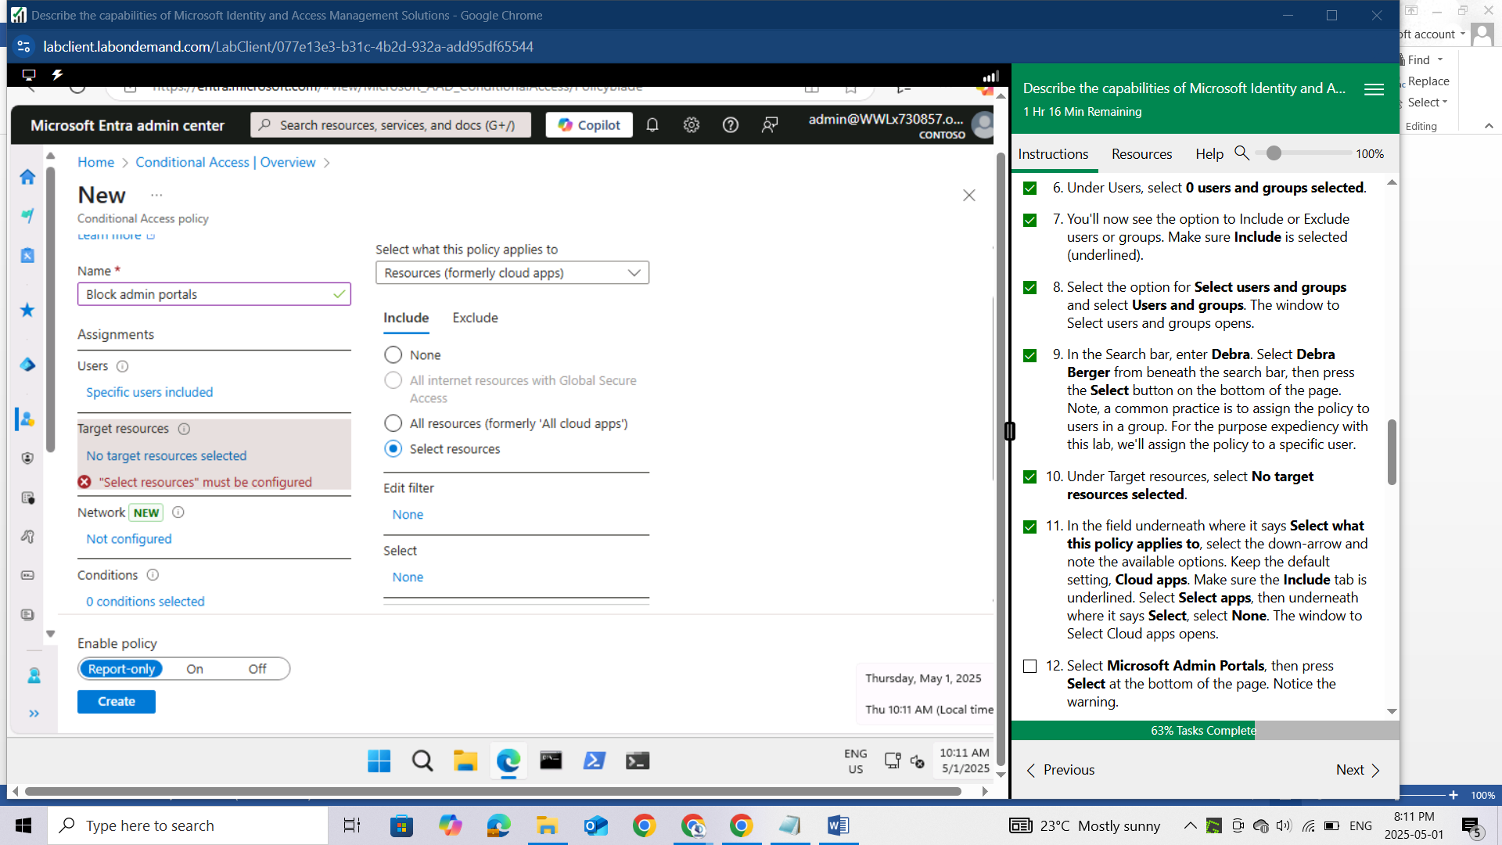

Select Microsoft Admin Portals, then press Select at the bottom of the page. Notice the warning.

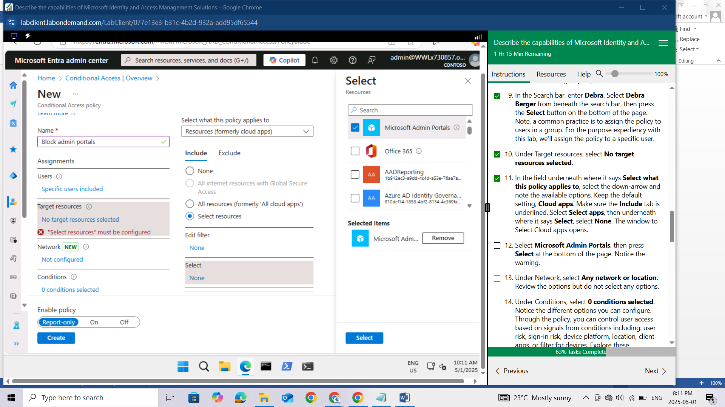

Under Network, select Any network or location. Review the options but do not select any options.

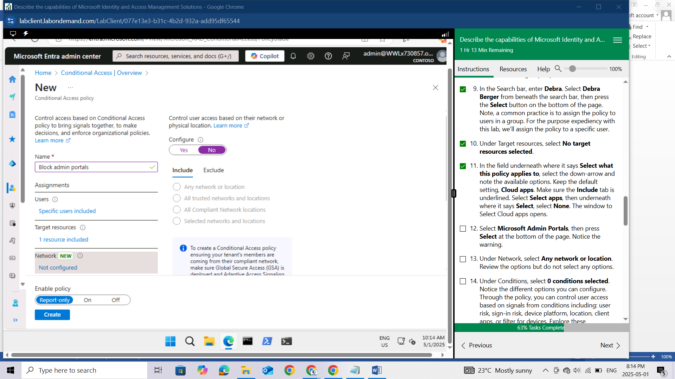

Under Conditions, select 0 conditions selected. Notice the different options you can configure. Through the policy, you can control user access based on signals from conditions including: user risk, sign-in risk, device platform, location, client apps, or filter for devices. Explore these configurable options, but do not set any conditions.

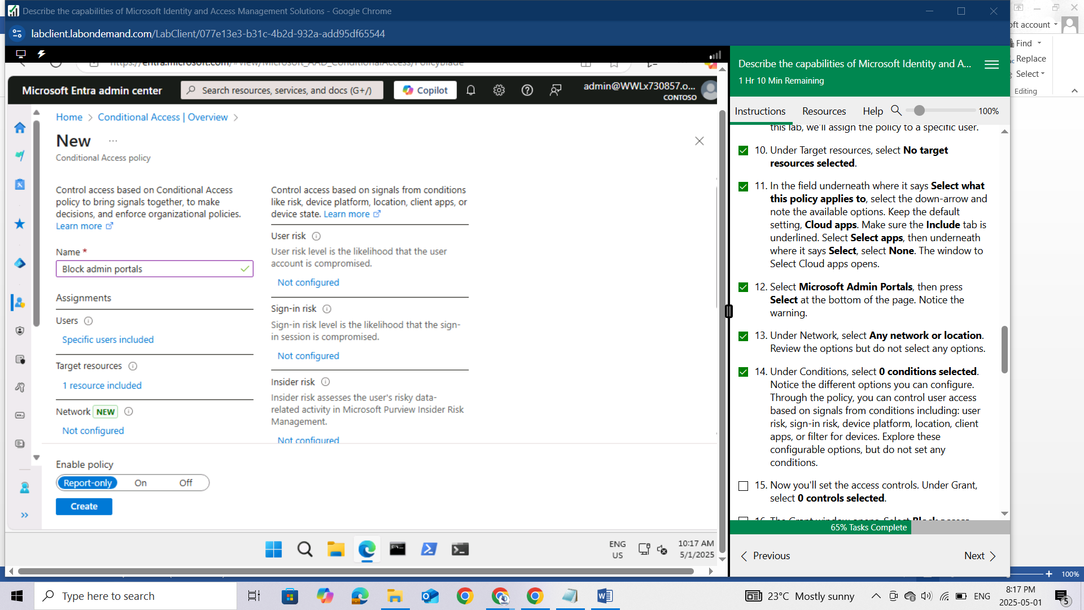

Now you'll set the access controls. Under Grant, select 0 controls selected

The Grant window opens. Select Block access. Press Select at the bottom of the page.

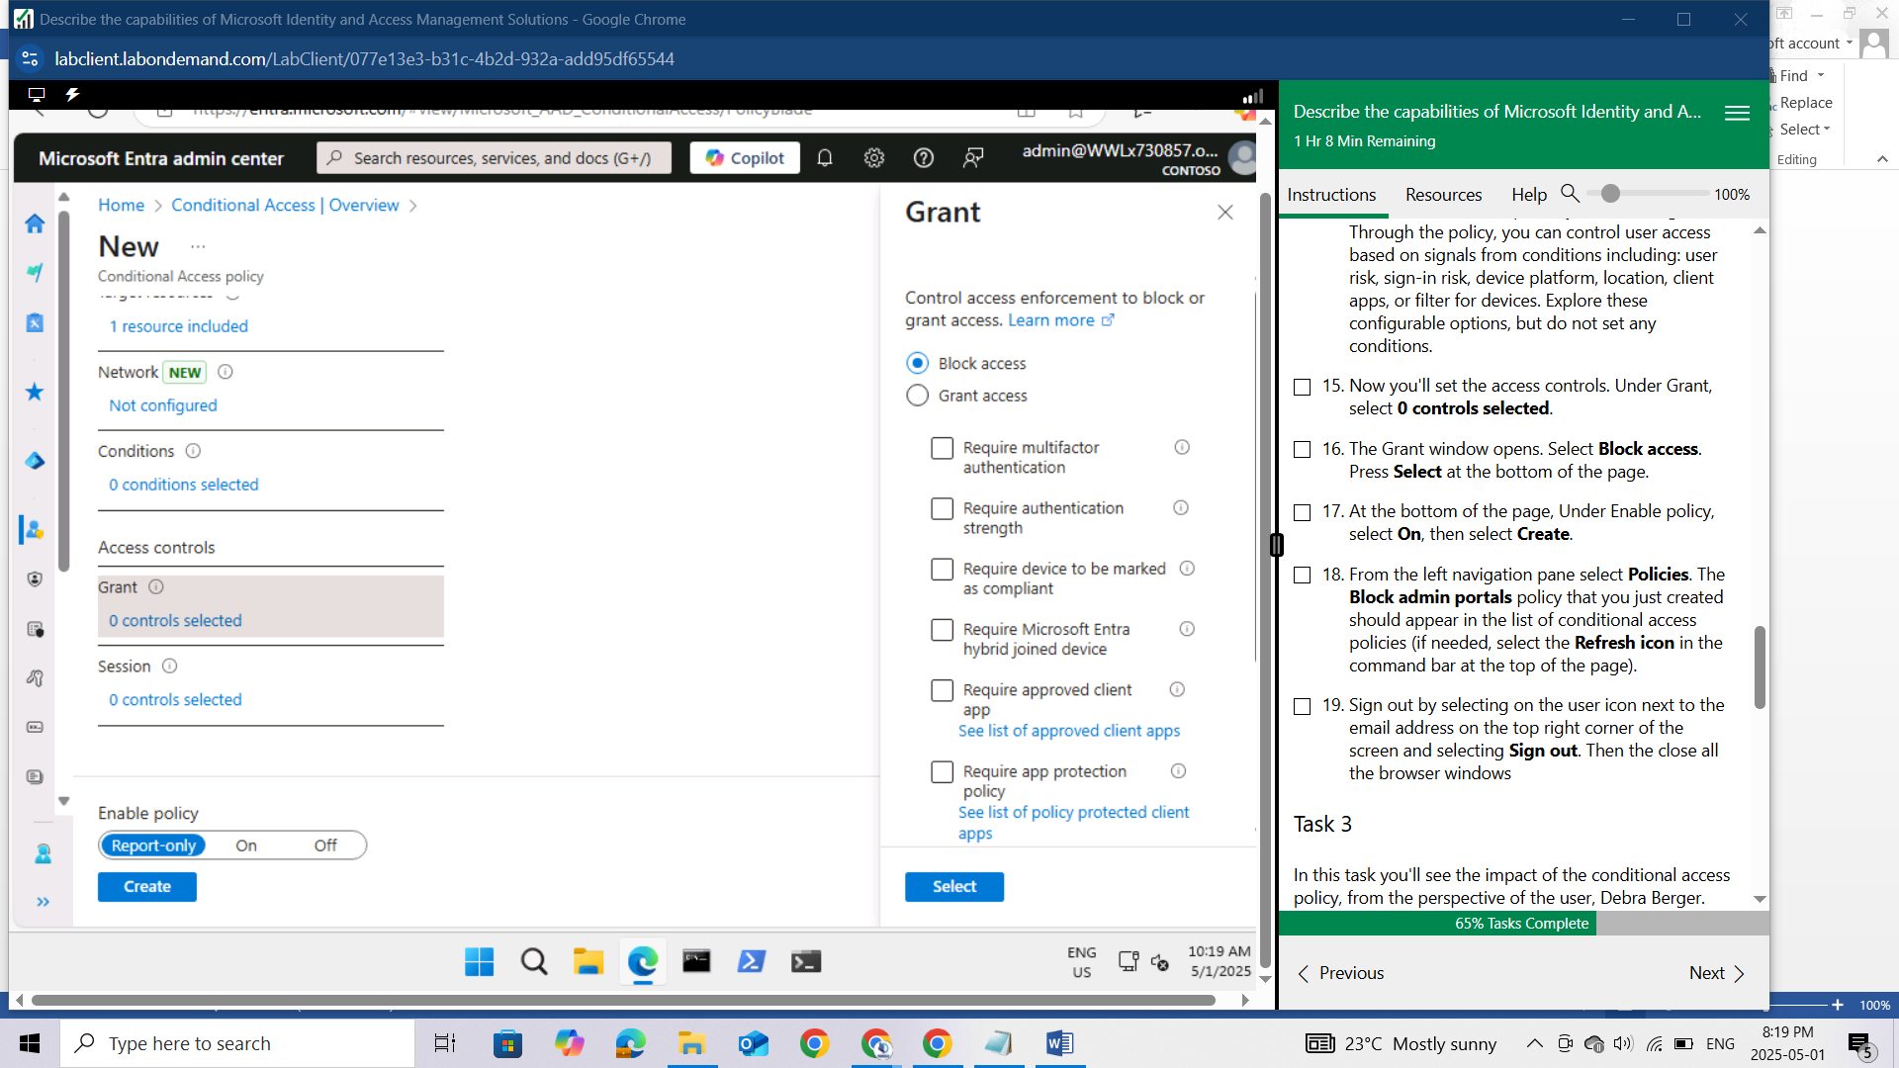

At the bottom of the page, Under Enable policy, select On, then select Create.

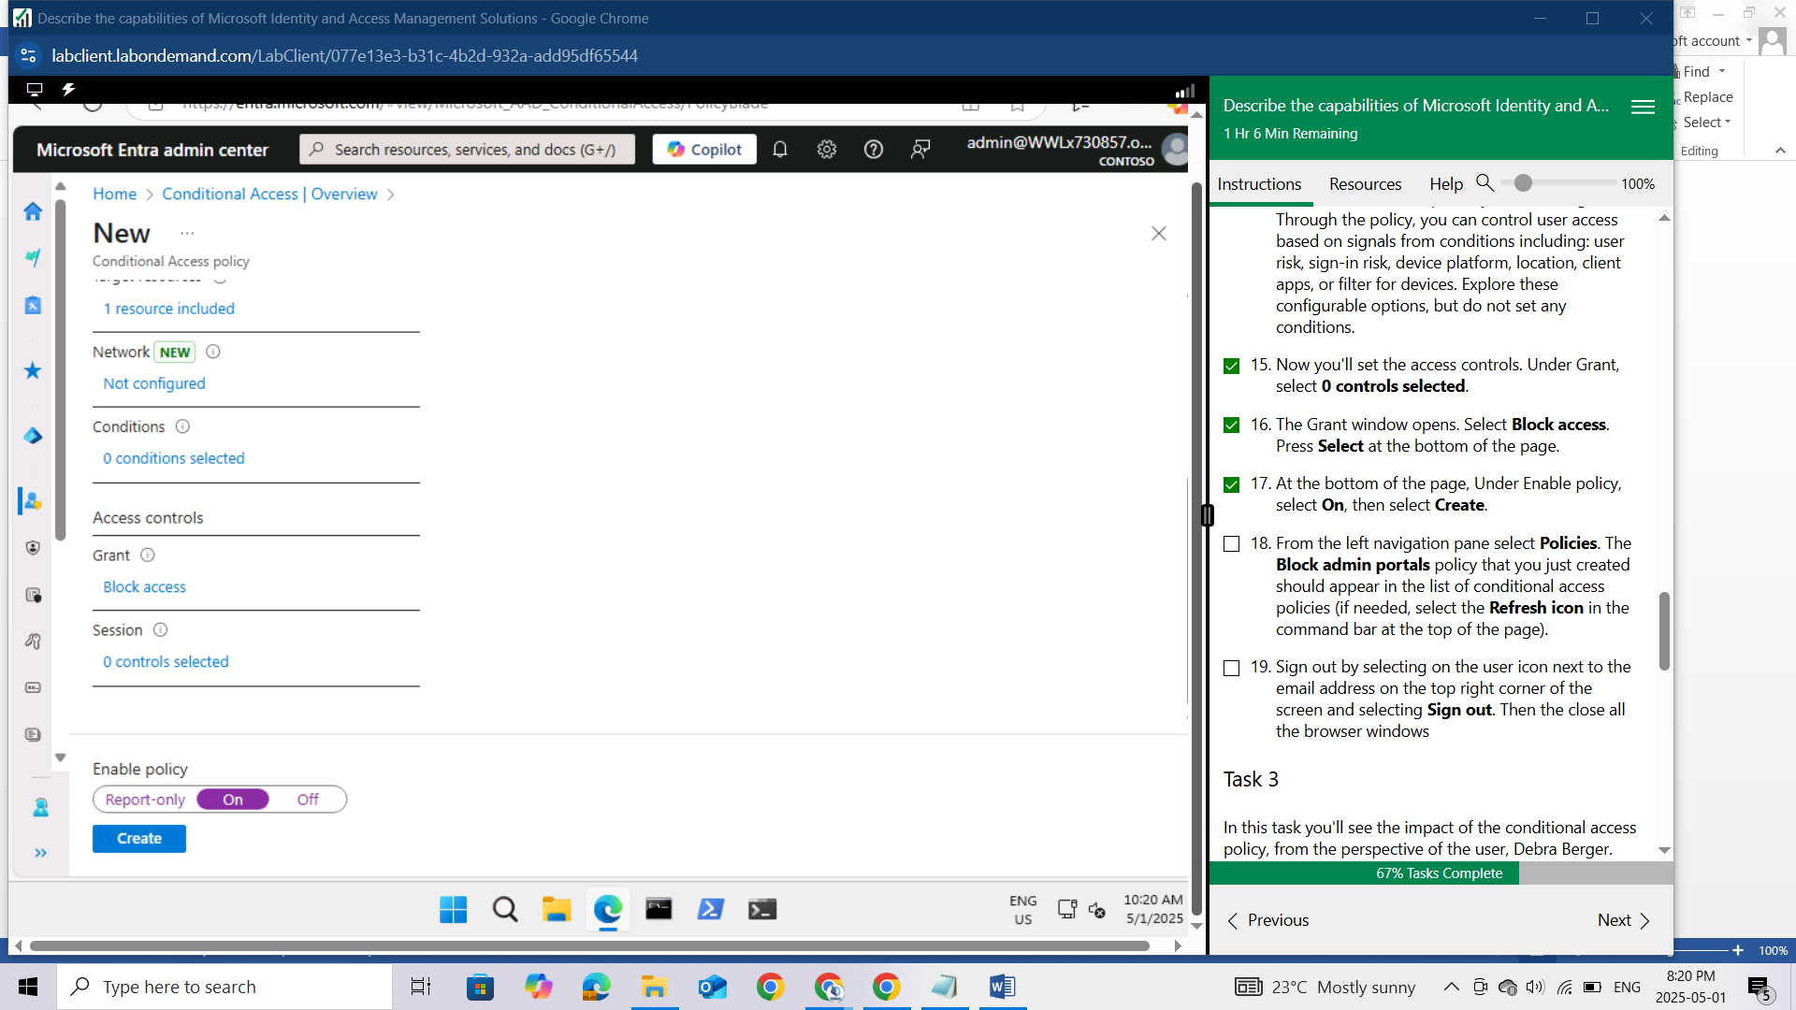

From the left navigation pane select Policies. The Block admin portals policy that you just created should appear in the list of conditional access policies (if needed, select the Refresh icon in the command bar at the top of the page).

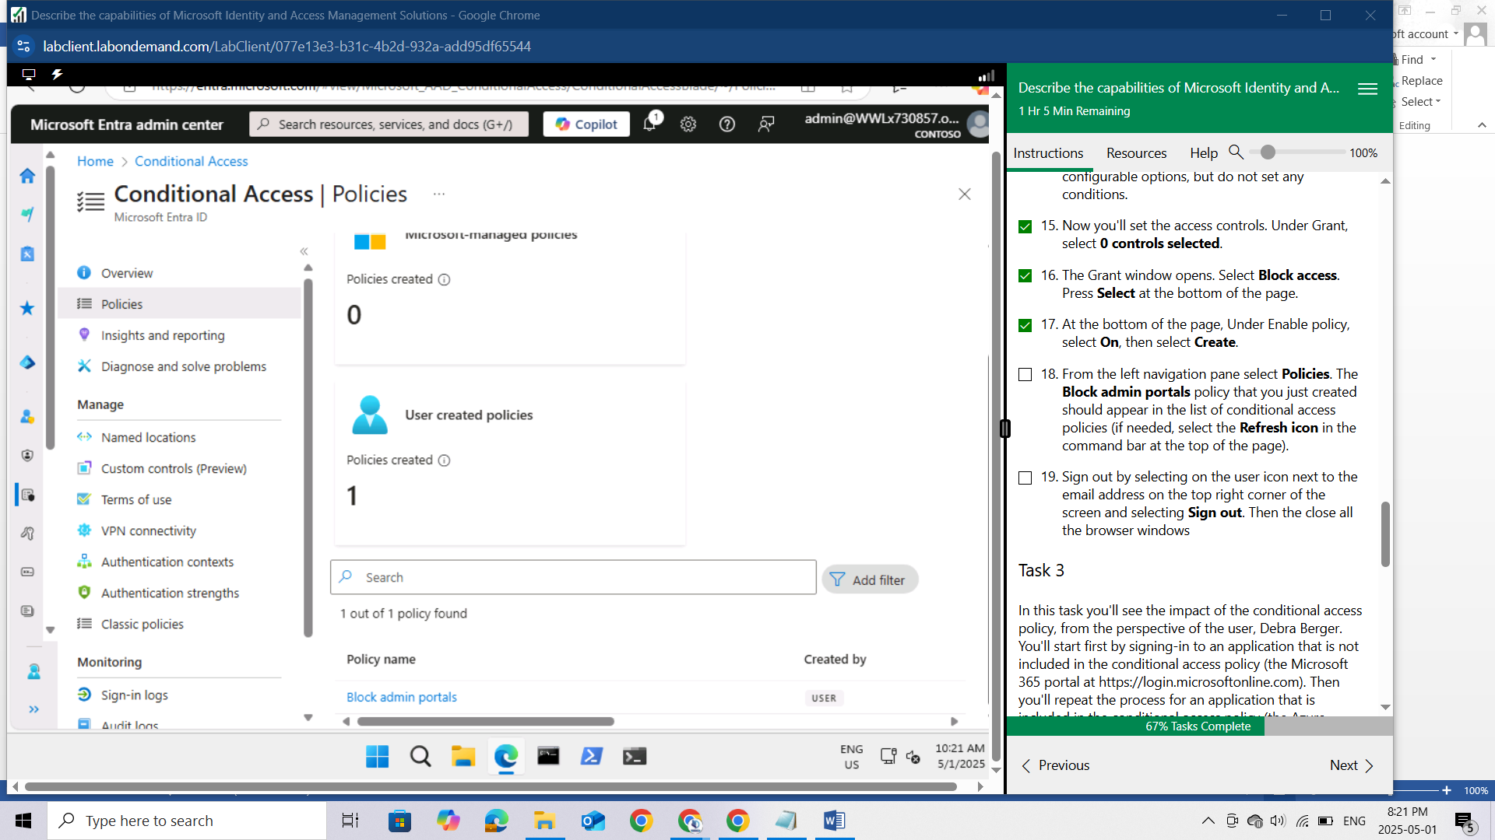

Sign out by selecting on the user icon next to the email address on the top right corner of the screen and selecting Sign out. Then the close all the browser windows

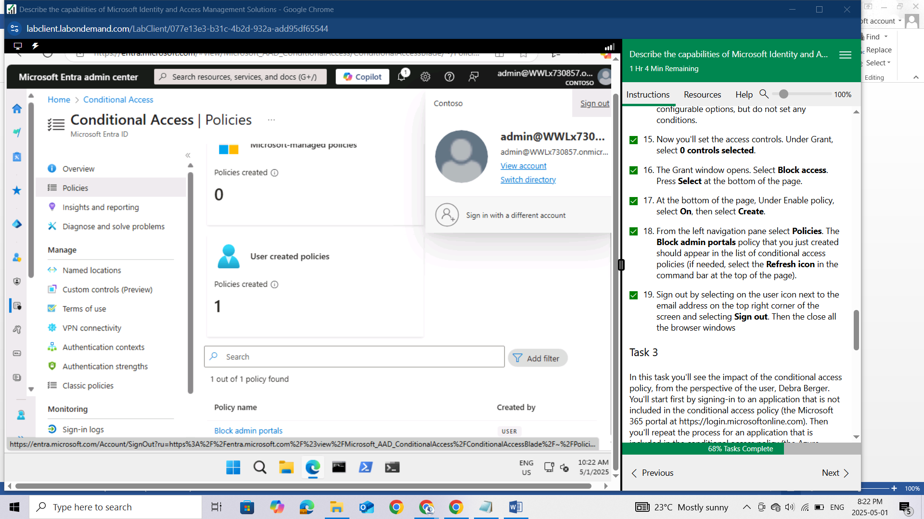

## Task 3

In this task you'll see the impact of the conditional access policy, from the perspective of the user, Debra Berger. You'll start first by signing-in to an application that is not included in the conditional access policy (the Microsoft 365 portal at https://login.microsoftonline.com). Then you'll repeat the process for an application that is included in the conditional access policy (the Azure portal at https://portal.azure.com). Recall that the policy blocks accessing any of the Microsoft Admin Portals, including the Azure portal. NOTE: For security reasons, all user accounts accessing any portal are required to use MFA. The MFA requirement is independent of this lab exercise.

Open Microsoft Edge. In the address bar, enter <https://login.microsoftonline.com>.

Sign in as DebraB@WWLx730857.onmicrosoft.com (where ZZZZZZ is your unique tenant ID provided by your lab hosting provider) then select Next.

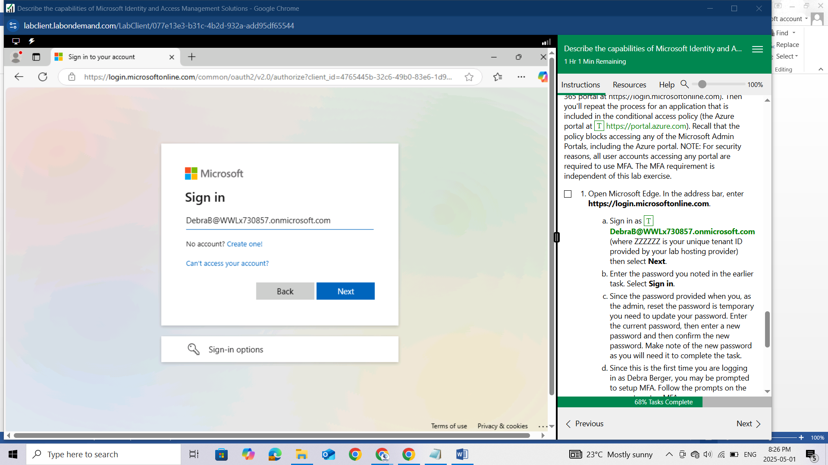

Enter the password you noted in the earlier task. Select Sign in.

Since the password provided when you, as the admin, reset the password is temporary you need to update your password. Enter the current password, then enter a new password and then confirm the new password. Make note of the new password as you will need it to complete the task.

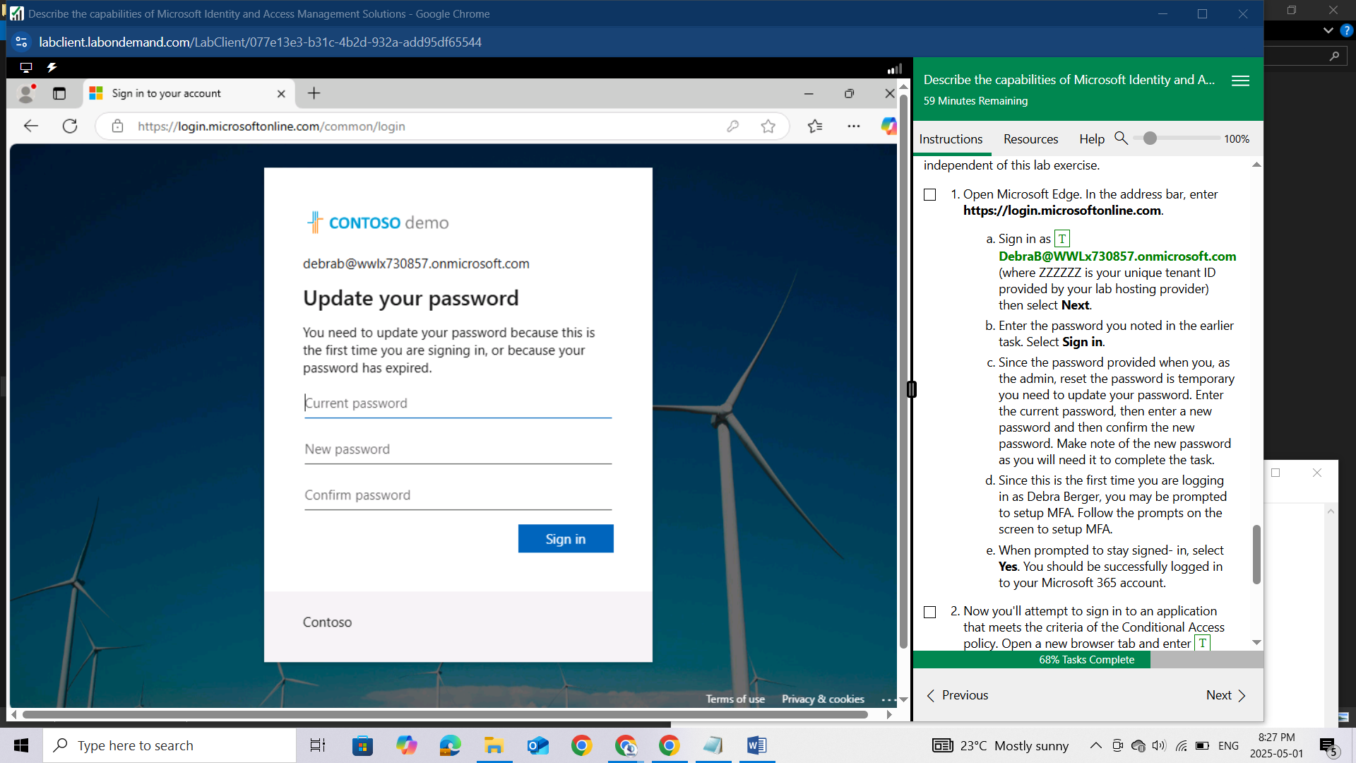

Since this is the first time you are logging in as Debra Berger, you may be prompted to setup MFA. Follow the prompts on the screen to setup MFA.

When prompted to stay signed- in, select Yes. You should be successfully logged in to your Microsoft 365 account.

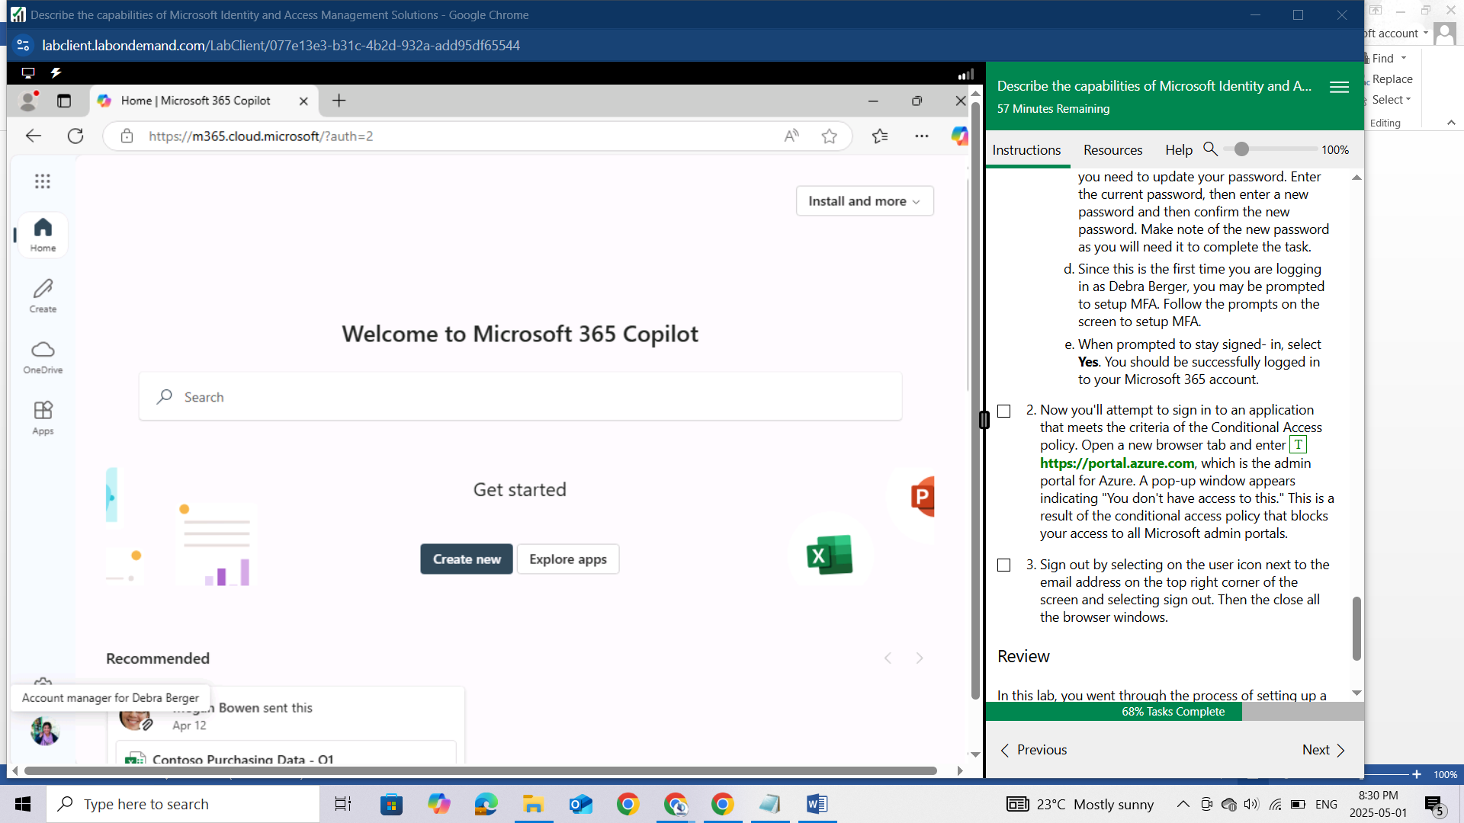

Now you'll attempt to sign in to an application that meets the criteria of the Conditional Access policy. Open a new browser tab and enter https://portal.azure.com, which is the admin portal for Azure. A pop-up window appears indicating "You don't have access to this." This is a result of the conditional access policy that blocks your access to all Microsoft admin portals.

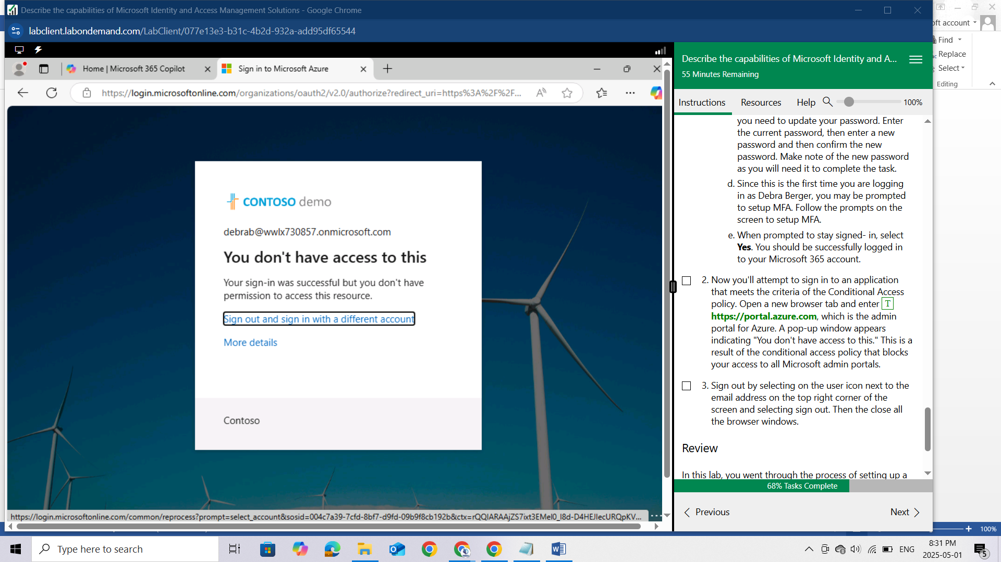

Sign out by selecting on the user icon next to the email address on the top right corner of the screen and selecting sign out. Then the close all the browser windows.

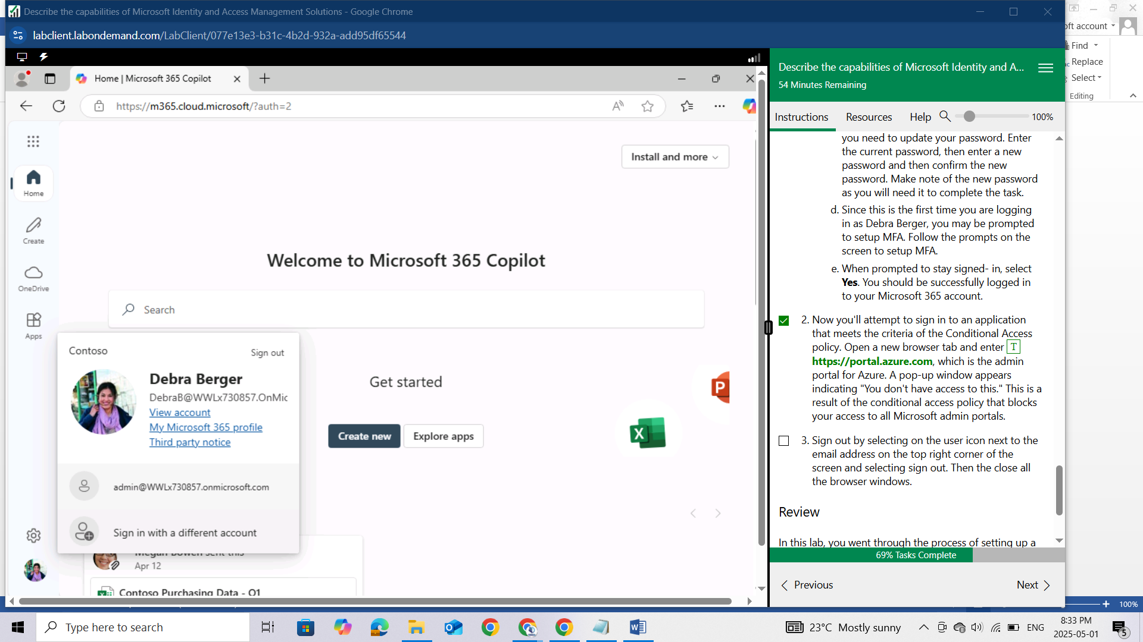

## Review

In this lab, you went through the process of setting up a conditional access policy that blocks access to Microsoft admin portals for all users included in the policy. Then, as a user you experienced the impact of the conditional access policy when accessing the Azure portal.